Olerup SSP®

PHOTO DOCUMENT

Olerup SSP® HLA-B*35

Prod. No: 101.522-24/24u
101.522-03/03u
Lot No: 16R
Expiry Date: 2015-May-01

Name:________________Sample ID:_______________

DNA Extract Date:_________ Conc.(ng/ul):_________

Test Date: _________Review Date:_______________

Tested By: _________Reviewed By:_______________

Interpretation:_________________________________

Specificities and sizes of the PCR products of the 79 primer mixes used for HLA-B*35 SSP typing.

Primer Mix | Size of spec. PCR product¹ | Size of control band² | Amplified HLA-B*35 alleles³ | Other amplified Class I alleles⁴
1⁵ | 95 bp | 800 bp | *35:01:01:01-35:09:03, 35:11:01-35:12:03, 35:14:01-35:15, 35:17-35:18, 35:20:01-35:24:02, 35:27, 35:29:01-35:45, 35:48, 35:50-35:62, 35:64-35:68:02, 35:70-35:72, 35:74-35:75, 35:77-35:79, 35:81-35:153, 35:155-35:185, 35:187-35:190, 35:192-35:197, 35:199-35:205 | *08:32, 18:01:01:01-18:11, 18:13-18:15, 18:17N-18:36, 18:38-18:47, 18:49-18:65, 18:67-18:76, 37:08, 38:06-38:07, 39:19:01-39:19:02, 44:06, 51:01:01-51:01:10, 51:01:12-51:24:04, 51:26-51:46, 51:48-51:103, 51:105-51:111, 51:113-51:117, 51:119-51:137, 53:01:01-53:16, 53:18-53:27, 78:01:01-78:04, 78:07
2 | 150 bp | 1070 bp | *35:01:01:01-35:04:03, 35:06-35:08:05, 35:10-35:17, 35:19-35:21, 35:23-35:30, 35:33-35:36, 35:38-35:42:02, 35:45-35:50, 35:52, 35:54-35:57, 35:59, 35:61-35:63, 35:65Q, 35:69-35:71, 35:74, 35:76-35:78, 35:80-35:85, 35:90-35:96, 35:98, 35:100-35:101:02, 35:103-35:113, 35:115-35:116, 35:120-35:126, 35:128-35:134N, 35:136-35:150, 35:152-35:173N, 35:175-35:184, 35:186-35:198, 35:200-35:204 | *08:49, 13:01:01-13:01:06, 13:06-13:07N, 13:12-13:13, 13:17, 13:20, 13:22:01-13:23, 13:25-13:26, 13:28-13:29, 13:36, 13:39, 13:43, 13:50-13:52, 13:57, 14:10, 15:02:01-15:02:06, 15:13:01-15:13:02, 15:20-15:21, 15:25:01-15:25:03, 15:36, 15:44, 15:62, 15:77, 15:80, 15:85, 15:88-15:89, 15:106, 15:112, 15:121, 15:139, 15:144, 15:154, 15:165, 15:170, 15:194, 15:204, 15:213-15:214, 15:223, 15:240, 15:250, 18:22, 18:69, 27:19, 27:30, 37:01:01-37:01:07, 37:03N-37:06, 37:08, 37:10-37:11, 37:13-37:34, 38:20, 39:42, 40:28, 44:02:01:01-44:14, 44:16-44:17, 44:19N, 44:21-44:30, 44:32-44:40, 44:42-44:46, 44:48-44:52N, 44:55-44:64:02, 44:66-44:98, 44:101-44:105, 44:107-44:134, 44:136-44:137, 44:139-44:155, 46:33, 48:02:01-48:02:02, 48:25, 50:17, 51:04, 51:42, 51:46, 51:56:01-51:56:02, 53:01:01-53:13, 53:15-53:28, 55:14, 56:09, 56:11-56:12, 57:01:01-57:01:04, 57:01:06-57:10, 57:12, 57:14-57:20, 57:22-57:30, 57:32-57:46, 57:48-57:58, 58:01:01-58:01:02, 58:01:04-58:01:11, 58:04-58:05, 58:09-58:15, 58:17N, 58:19, 58:21-58:24, 58:28-58:37, 83:01, C*03:102
3^{5,8} | 115 bp | 1070 bp | *35:01:01:01-35:01:31, 35:03:01, 35:03:03-35:03:11, 35:05:01-35:05:03, 35:07-35:08:05, 35:10-35:11:01, 35:13-35:14:01, 35:15-35:17, 35:19-35:21, 35:23-35:30, 35:32:01-35:42:02, 35:45-35:58, 35:61-35:63, 35:65Q-35:66, 35:68:01-35:72, 35:74-35:78, 35:80, 35:82, 35:84-35:85, 35:89-35:94, 35:96-35:98, 35:100-35:101:02, 35:103-35:113, 35:115-35:116, 35:119-35:120, 35:122-35:128, 35:130N-35:134N, 35:136-35:148, 35:150-35:153, 35:155-35:156, 35:158-35:161, 35:163, 35:165N-35:171, 35:173N-35:181, 35:186-35:200, 35:202-35:204 | *07:02:13, 07:22:02, 07:68:02, 08:07, 08:37, 08:89, 13:26, 13:35, 14:23, 15:03:02, 15:05:02, 15:20, 15:27:03, 15:38:02, 15:39:02, 15:179, 18:01:01:01-18:01:09, 18:01:11-18:15, 18:17N-18:19, 18:22-18:25, 18:27-18:56, 18:58-18:60, 18:62-18:76, 27:34, 37:09, 38:29, 39:07, 39:15, 39:29, 39:43, 39:49, 39:55, 41:04, 41:18, 41:21, 42:09, 42:16, 44:17, 44:43:01, 44:45, 44:51, 44:107, 44:123, 44:135, 45:09, 46:01:03, 46:13:01, 46:21:02, 46:33, 48:02:01-48:02:02, 48:25, 49:04, 51:37, 51:45, 51:90, 51:92, 51:135, 52:12, 53:01:01-53:01:02, 53:01:04-53:06, 53:08:01, 53:09-53:18, 53:20-53:28, 54:09, 54:14, 54:16, 55:14, 55:23, 55:27, 55:46, 56:09, 56:11, 56:18, 56:31-56:32, 57:14, 58:01:01-58:01:04, 58:01:06-58:02, 58:04-58:07, 58:09-58:19, 58:21-58:26, 58:29-58:37, C*01:71, C*02:02:19, C*02:23, C*02:36, C*07:01:24, C*07:123, C*07:173, C*07:178, C*07:182, C*15:02:05, C*15:06:03
4 | 280 bp | 1070 bp | *35:01:01:01-35:01:31, 35:05:01-35:05:03, 35:07-35:08:05, 35:10-35:11:02, 35:14:01-35:17, 35:19-35:21, 35:23-35:30, 35:32:01-35:32:02, 35:35, 35:37, 35:40N-35:43:01, 35:45-35:54, 35:57-35:58, 35:61-35:64, 35:66-35:69, 35:71-35:72, 35:76-35:80, 35:82, 35:86, 35:89-35:94, 35:97, 35:99-35:105, 35:107-35:108:02, 35:110-35:126, 35:130N-35:135, 35:137-35:148, 35:158-35:159, 35:161, 35:165N-35:166, 35:168, 35:170-35:171, 35:173N-35:178, 35:180, 35:185-35:192, 35:194, 35:196-35:197, 35:200, 35:202-35:203 | *07:09, 07:11, 07:17, 07:162, 08:28, 08:35, 08:37, 08:89, 13:04, 13:10, 13:26, 15:01:01:01-15:01:04, 15:01:06-15:08, 15:11:01-15:16:03, 15:18:01-15:21, 15:23-15:29, 15:31-15:36, 15:38:01-15:40, 15:43-15:44, 15:46-15:47:02, 15:49-15:57, 15:60-15:62, 15:64-15:72, 15:74-15:76, 15:78:01-15:82, 15:84-15:85, 15:87-15:89, 15:91-15:98, 15:101-15:129, 15:131-15:132, 15:134-15:136, 15:138-15:149N, 15:151-15:161, 15:163-15:167, 15:169-15:176, 15:178-15:187, 15:189-15:195, 15:197-15:207, 15:209N-15:215, 15:217-15:223, 15:225-15:228, 15:231-15:232, 15:234-15:242, 15:244-15:247, 15:249-15:251, 15:254, 18:01:01:01-18:15, 18:17N-18:25, 18:27-18:40, 18:42-18:60, 18:62-18:76, 27:41, 39:07, 39:43, 40:03, 40:20, 40:38, 40:52, 40:59-40:60, 40:105, 40:158-40:159, 42:09, 44:17, 44:43:01-44:43:02, 44:144, 45:09, 46:01:01-46:10, 46:12-46:17, 46:19-46:34, 48:02:01-48:02:02, 48:14, 48:23, 48:25, 49:04-49:05, 51:37, 51:45, 51:63, 51:97, 53:01:01-53:03, 53:05-53:06, 53:08:01-53:18, 53:20-53:28, 54:06, 54:09, 54:14, 55:14, 55:23, 55:32, 56:03, 56:09, 56:18, 56:31-56:32, 57:01:01-57:01:13, 57:06, 57:08, 57:10-57:11, 57:13-57:16, 57:18-57:27, 57:29-57:31, 57:33-57:38, 57:40-57:41, 57:43-57:45, 57:47-57:56, 57:58, 58:01:01-58:02, 58:04-58:07, 58:09-58:19, 58:21-58:26, 58:29-58:33, 58:35-58:37
5 | 295 bp | 800 bp | *35:02:01-35:02:04, 35:04:01-35:04:03, 35:06, 35:09:01-35:09:03, 35:12:01-35:12:03, 35:18, 35:22, 35:31, 35:44, 35:59-35:60, 35:81, 35:83, 35:87-35:88, 35:95, 35:129N, 35:146, 35:149, 35:154, 35:157, 35:162, 35:172, 35:182-35:184, 35:201 | *07:05:01-07:06, 07:32, 07:34, 07:40, 07:53, 07:69, 07:78, 07:80, 07:90, 07:97, 07:105, 07:112, 07:123, 07:137-07:138, 07:140, 08:01:01-08:05, 08:08N-08:13, 08:15-08:27, 08:29-08:36, 08:38-08:48, 08:50-08:73, 08:75-08:86N, 08:88, 08:90-08:94, 13:01:01-13:01:02, 13:01:04-13:03, 13:06-13:09, 13:11-13:23, 13:25, 13:27-13:33, 13:36-13:45, 13:47-13:50, 13:52-13:58, 14:13, 15:09, 15:30, 15:42, 15:48, 15:58, 15:73, 15:83, 15:86, 15:150, 15:188, 15:224, 15:229, 15:243, 15:252, 18:26, 18:61, 27:07:01-27:07:02, 27:11, 27:20, 27:24, 27:27, 27:33, 27:43, 37:12, 38:01:01, 38:01:03-38:21, 38:23-38:28, 38:30-38:40, 39:01:01:01-39:01:01:03, 39:01:03-39:06:02, 39:08-39:14, 39:16, 39:18-39:20, 39:22-39:24:02, 39:26-39:28, 39:30-39:42, 39:44-39:48, 39:50-39:54, 39:56-39:75, 40:01:01-40:02:09, 40:02:11-40:02:15, 40:04-40:08, 40:10:01-40:16, 40:19, 40:21-40:23, 40:25-40:30, 40:34-40:40, 40:43, 40:45-40:51, 40:53-40:58, 40:61-40:88, 40:90-40:97, 40:99-40:119, 40:121-40:123, 40:125-40:130, 40:132-40:158, 40:160-40:171, 40:173-40:179, 40:181-40:186, 40:188-40:215, 41:01-41:03:02, 41:05-41:09, 41:11-41:17, 41:19-41:20, 42:01:01-42:02, 42:04-42:08, 42:10-42:15, 42:17, 44:10, 44:14, 44:31, 44:62, 44:77, 44:82, 45:12, 45:14, 46:11, 46:18, 48:01:01-48:01:03, 48:03:01-48:07, 48:09-48:16, 48:18-48:22, 48:24, 48:27-48:28, 51:01:01-51:01:30, 51:01:32-51:02:02, 51:02:04-51:16, 51:19-51:24:04, 51:26-51:36, 51:38-51:41N, 51:43-51:44N, 51:46, 51:48-51:84, 51:86-51:89, 51:91, 51:93, 51:95-51:134, 51:136-51:137, 52:01:01:01-52:01:10, 52:01:12-52:11, 52:13-52:25, 52:27-52:30, 53:19, 54:01:01-54:05N, 54:07-54:08N, 54:10-54:13, 54:17-54:27, 55:01:01-55:05, 55:07-55:13, 55:15-55:22, 55:24-55:26, 55:28-55:40, 55:42-55:45, 55:47-55:56, 56:01:01-56:02, 56:04-56:08, 56:10, 56:12-56:17, 56:19N-56:30, 56:33-56:36, 57:02:01-57:03:02, 57:07, 57:09, 57:12, 57:17, 57:28N, 57:39, 57:42, 57:46, 57:57, 58:08:01-58:08:02, 58:20, 58:27-58:28, 59:01:01:01-59:05, 67:01:01-67:03, 78:01:01-78:07, 81:01-81:05, 82:01-82:03
6^{5,8} | 85 bp | 1070 bp | *35:02:01-35:02:04, 35:04:01-35:04:03, 35:12:01-35:12:03, 35:22, 35:34, 35:39, 35:44, 35:81, 35:83, 35:95, 35:129N, 35:149, 35:154, 35:157, 35:162, 35:172, 35:182-35:184, 35:199, 35:201 | *07:68:01-07:68:03, 07:100, 08:71, 13:13, 13:35, 14:13, 14:23, 15:09-15:10:02, 15:30, 15:37, 15:45, 15:48, 15:63, 15:83, 15:90, 15:99, 15:243, 15:252, 18:26, 27:27, 27:76, 39:14, 39:29, 39:70, 40:26, 40:28, 40:35, 40:87:01-40:87:02, 40:95, 40:121, 42:10, 42:17, 44:62, 44:77, 44:82, 44:107, 44:123, 48:12, 49:18, 50:14, 51:01:01-51:01:14, 51:01:16-51:09:02, 51:11N-51:12, 51:16, 51:18-51:23, 51:26-51:36, 51:38-51:41N, 51:43-51:44N, 51:46, 51:48-51:61:02, 51:64-51:80, 51:82-51:84, 51:86-51:91, 51:93-51:96, 51:98N-51:105, 51:107-51:137, 52:01:01:01-52:13, 52:15-52:24, 52:27-52:30, 53:19, 54:04, 55:17, 55:27-55:28, 56:05:01-56:06, 56:12, 56:15, 56:21, 57:02:01-57:03:02, 57:05, 57:07, 57:09, 57:12, 57:17, 57:28N, 57:39, 57:42, 57:46, 57:57, 58:08:01-58:08:02, 58:28, 78:01:01-78:07
7^{6,8,13} | 160 bp, 330 bp | 800 bp | *35:23, 35:84, 35:90, 35:150, 35:184, 35:201 | *13:36, 15:06, 15:27:01-15:27:03, 15:84, 15:109, 15:195, 18:27, 27:23, 27:92, 38:16, 40:08, 40:25, 40:68, 40:100, 40:106, 40:166^{w}, 44:10, 44:12, 47:01:01:01-47:03, 47:06-47:08, 50:15, 51:103, 51:119, 56:36^{w}, 73:01^{w}-73:02^{w}, 82:01-82:02
8⁹ | 280 bp | 1070 bp | *35:03:01-35:03:11, 35:06, 35:13, 35:33, 35:36, 35:38, 35:55-35:56, 35:59-35:60, 35:65Q, 35:70, 35:74-35:75, 35:84-35:85, 35:96, 35:98, 35:106, 35:109, 35:127-35:128, 35:136, 35:150-35:153, 35:155-35:156, 35:160, 35:163, 35:167, 35:169, 35:179, 35:181, 35:193, 35:195, 35:198, 35:204-35:205 | *07:78, 08:69, 13:01:01-13:03, 13:06-13:09, 13:11-13:12, 13:14-13:20, 13:22:01-13:23, 13:25, 13:27-13:34, 13:36-13:45, 13:47-13:50, 13:52-13:58, 15:42, 15:58, 15:73, 15:86, 15:133, 15:224, 15:229, 15:253, 38:01:01-38:21, 38:23-38:40, 39:01:01:01-39:01:01:03, 39:01:03-39:06:02, 39:08-39:13:02, 39:15-39:16, 39:18-39:20, 39:22-39:24:02, 39:26-39:28, 39:30-39:42, 39:44-39:69, 39:71-39:75, 40:36, 40:48, 40:71, 40:77, 40:86, 40:184, 41:18, 42:06, 44:10, 45:14, 46:11, 46:18, 48:07, 51:13:01-51:13:02, 51:15, 51:62, 51:92, 51:106, 52:14, 52:25, 53:04, 54:01:01-54:03, 54:05N, 54:07-54:08N, 54:10, 54:12-54:13, 54:16-54:27, 55:01:01-55:03, 55:05, 55:07, 55:09-55:13, 55:15-55:16, 55:18-55:19, 55:21-55:22, 55:24-55:26, 55:29-55:31, 55:33-55:40, 55:42-55:48, 55:50, 55:52-55:56, 56:01:01-56:02, 56:04, 56:07-56:08, 56:10-56:11, 56:13-56:14, 56:16-56:17, 56:19N-56:20:02, 56:22-56:30, 56:33-56:36, 58:20, 58:34, 59:01:01:01-59:01:01:02, 59:03-59:05, 67:01:01-67:03, 82:01-82:03
9 | 140 bp | 800 bp | *35:05:01-35:05:03, 35:16-35:17, 35:22, 35:30, 35:51, 35:58, 35:66, 35:72, 35:89, 35:97, 35:113, 35:125, 35:164, 35:199 | *07:68:01-07:68:03, 07:100, 08:71, 14:05, 14:13, 15:07:01-15:07:02, 15:45, 15:55, 15:68, 15:126, 15:207, 18:14, 18:22, 27:32, 38:19, 39:03, 39:14, 39:24:01-39:24:02, 39:29, 39:37, 40:35, 40:71, 42:10, 42:17, 44:54, 44:106, 44:110, 44:135, 46:12, 48:12, 48:14, 51:64, 53:14, 58:18
10^{8,14} | 140 bp, 240 bp | 1070 bp | *35:07, 35:83 | C*07:63
11 | 225 bp | 800 bp | *35:08:01-35:08:05, 35:18, 35:45, 35:61, 35:80, 35:100, 35:105, 35:142, 35:156, 35:158, 35:164, 35:172, 35:174, 35:176, 35:187, 35:192 | *07:12, 07:14, 07:18:01-07:18:02, 07:137, 07:162, 44:04, 44:28:01-44:28:02, 44:56N, 44:76, 44:150, 53:11, 53:16, 53:24, 57:02:01-57:02:02, 57:04-57:05, 57:12-57:13, 57:19, 57:28N, 57:30, 57:42, 58:22, A*01:41^{w}, C*01:49-01:50, C*03:28, C*03:49, C*03:117, C*04:80, C*04:100, C*04:110, C*05:10, C*15:08
12^{5,15} | 95 bp,  125 bp | 1070 bp | *35:10, 35:13, 35:16, 35:28, 35:69, 35:80, 35:92 | *13:58, 15:202, 15:239, 18:12, 37:01:01-37:01:05, 37:01:07-37:05, 37:07, 37:09-37:27, 37:29-37:34, 40:185, 40:209, 44:83, 44:134, 49:03, 52:01:01:01-52:01:12, 52:03-52:15, 52:17, 52:19-52:30, 53:17:01-53:17:02, 53:28, 78:05-78:06
13 | 170 bp | 800 bp | *35:11:01-35:11:02, 35:14:01-35:14:02, 35:21, 35:43:01-35:44, 35:58, 35:67, 35:79, 35:86, 35:96, 35:99, 35:102, 35:117-35:118, 35:135, 35:167, 35:185, 35:188 | *07:02:01-07:24, 07:26-07:47, 07:49N-07:50, 07:52-07:154, 07:156-07:162, 08:20, 08:53, 08:79, 13:16, 13:20, 13:31, 13:48, 14:01:01-14:32, 15:01:01:01-15:01:04, 15:01:06-15:04, 15:06-15:19, 15:21, 15:23-15:30, 15:32-15:40, 15:42-15:47:02, 15:49-15:50, 15:53-15:54, 15:56-15:58, 15:60-15:74, 15:76-15:82, 15:85, 15:87, 15:89-15:90, 15:92-15:99, 15:101-15:104, 15:106,  15:108-15:110, 15:112-15:113, 15:115-15:122, 15:125-15:129, 15:131-15:135, 15:137-15:144, 15:146-15:150, 15:152-15:154, 15:156-15:161, 15:163-15:175, 15:177-15:178, 15:180-15:184, 15:187, 15:189-15:199, 15:201-15:217, 15:219-15:221, 15:223, 15:225-15:234, 15:236, 15:238-15:249, 15:251-15:254, 18:15, 18:19, 18:21, 18:30, 18:57, 27:04:01-27:04:03, 27:06, 27:10, 27:15, 27:18, 27:20-27:21, 27:24-27:25, 27:40, 27:54, 27:63, 27:66N, 27:68-27:69, 27:79, 27:86, 27:91-27:92, 37:07, 37:13, 38:10, 38:32, 39:18, 39:35-39:36, 40:05, 40:15-40:16, 40:23, 40:26, 40:28, 40:32, 40:51, 40:95, 40:98, 40:148, 40:158, 40:161, 40:174, 40:183, 40:198, 44:76, 44:79, 44:146, 44:150, 46:01:01-46:05, 46:07N-46:08, 46:10, 46:12, 46:14-46:17, 46:20, 46:22-46:24, 46:26-46:32, 46:34, 48:05, 48:08, 48:15, 48:25, 49:01:01-49:10, 49:12-49:22, 50:01:01-50:02, 50:04-50:17, 51:01:01-51:04, 51:06:01-51:07:02, 51:11N-51:14, 51:16-51:18, 51:21-51:24:04, 51:26-51:30, 51:32-51:39, 51:41N, 51:43, 51:45-51:46, 51:48-51:52, 51:55-51:72, 51:74-51:80, 51:82-51:92, 51:94-51:96, 51:98N-51:107, 51:109-51:114, 51:116-51:119, 51:121, 51:123-51:137, 52:01:01:01-52:02, 52:04-52:09, 52:11-52:18, 52:20-52:27, 52:30, 53:06, 53:08:01-53:08:02, 53:28, 54:06, 54:20, 55:01:01-55:01:09, 55:03, 55:05, 55:09, 55:11, 55:14-55:15, 55:17, 55:21, 55:24-55:25, 55:28-55:29, 55:31, 55:33, 55:36, 55:38, 55:40, 55:44-55:45, 55:52-55:53, 55:55N-55:56, 56:03, 56:05:01-56:06, 56:21, 56:25, 56:32, 57:09, 57:13, 57:22, 57:57, 58:06, 58:08:01-58:08:02, 58:19, 78:01:01-78:03, 78:05-78:07
14^{5,10} | 75 bp | 800 bp | *35:01:17, 35:03:07, 35:04:03, 35:12:01-35:12:03, 35:39, 35:59, 35:61, 35:88, 35:149, 35:164, 35:201 | *07:14, 07:18:01-07:18:02, 07:137, 08:60, 13:01:01-13:01:06, 13:06-13:07N, 13:12-13:13, 13:17, 13:20-13:23, 13:25, 13:28-13:29, 13:36, 13:39, 13:43, 13:50-13:52, 13:57, 14:10, 15:02:01-15:02:06, 15:13:01-15:13:02, 15:21, 15:25:01-15:25:03, 15:36, 15:44, 15:77, 15:80, 15:88-15:89, 15:106, 15:112, 15:121, 15:139, 15:144, 15:154, 15:170, 15:204, 15:213-15:214, 15:223, 15:240, 15:250, 27:19, 27:30, 38:20, 39:42, 40:04, 40:28, 40:30, 40:34, 40:64, 40:68, 40:129, 40:137, 40:160, 42:13, 44:02:01:01-44:02:05, 44:02:07-44:02:11, 44:02:13-44:09, 44:11-44:14, 44:16-44:17, 44:19N, 44:21-44:30, 44:32-44:35, 44:37:01-44:40, 44:42-44:46, 44:48-44:53, 44:55-44:64:02, 44:66-44:81, 44:83-44:86, 44:88-44:98, 44:101-44:105, 44:107-44:118, 44:120-44:134, 44:136-44:137, 44:139, 44:141-44:150, 44:152-44:155, 51:04, 51:42, 51:46, 51:56:01, 53:17:01, 55:14, 56:12, 57:01:01-57:04, 57:06-57:10, 57:12-57:20, 57:22-57:32, 57:34-57:39, 57:41-57:47, 57:49-57:58, 58:28, 83:01, C*03:40:03, C*04:110
15 | 135 bp | 1070 bp | *35:15, 35:33, 35:66, 35:86 | *07:68:01-07:68:03, 13:01:01-13:02:13, 13:07N-13:11, 13:13-13:20, 13:22:01-13:23, 13:25-13:45, 13:47, 13:49N-13:52, 13:54-13:58, 15:40, 15:47:01-15:47:02, 15:49, 15:52, 15:114, 15:117, 15:124, 15:138, 15:238, 15:241, 18:10, 18:35, 18:50, 27:01-27:06, 27:08-27:10, 27:12-27:14, 27:16-27:19, 27:21, 27:23, 27:26-27:27, 27:29-27:32, 27:35, 27:37, 27:39-27:42, 27:44-27:46, 27:48-27:61, 27:64N-27:70, 27:72-27:75, 27:77-27:89, 27:91-27:92, 37:02, 39:47, 39:50, 40:35, 40:77, 40:87:01-40:87:02, 40:95, 40:121, 40:158, 44:16, 44:21, 44:64:01-44:64:02, 44:124, 44:150, 45:10, 46:25, 46:30, 47:01:01:01-47:07, 48:12, 48:14, 48:26, 49:07, 51:16, 51:31, 51:34, 51:82, 51:93, 52:08, 54:26, 55:09, 55:22, 55:24, 57:25, 58:37, C*02:56
16^{5,16} | 95 bp,  190 bp | 1070 bp | *35:19, 35:47, 35:77, 35:154 | *07:133^{w}, 15:143, 18:48, 39:69, 40:08, 40:25, 40:68, 40:106, 40:166^{w}, 44:12, 50:15, 51:112
17¹¹ | 180 bp | 1070 bp | *35:26 | *14:11, 14:28, 15:189, 38:33, 39:04
18^{5,17} | 105 bp, 180 bp | 800 bp | *35:20:01-35:20:02, 35:28, 35:35, 35:72, 35:93, 35:95, 35:188, 35:190 | *08:37, 08:89, 13:58, 15:50, 15:69, 15:93, 15:186, 15:199, 15:202, 15:239, 18:01:01:01-18:15, 18:17N-18:76, 37:01:01-37:01:05, 37:01:07-37:05, 37:07-37:20, 37:22-37:25, 37:27, 37:29-37:34, 39:07, 39:43, 40:185, 40:209, 42:09, 44:83, 44:134, 46:03, 46:21:01-46:21:02, 46:29, 49:03, 51:07:01-51:07:02, 52:01:01:01-52:01:12, 52:03-52:05, 52:07-52:15, 52:17-52:21, 52:24-52:30, 53:09, 53:17:01-53:17:02, 53:28, 54:09, 54:14, 55:14, 55:23, 56:18, 56:31-56:32, 57:26, 58:05, 58:35, 78:05-78:06, C*07:123, 07:173, C*15:09, C*15:19, C*15:27, C*15:61, C*16:20
19 | 230 bp | 1070 bp | *35:29:01-35:29:02, 35:69, 35:74, 35:76, 35:136, 35:186, 35:198 | *07:29, 07:65, 07:72, 07:86, 08:01:01-08:01:17, 08:02^{w}, 08:04-08:05, 08:07-08:22, 08:24-08:53, 08:55-08:65, 08:67N-08:71, 08:73-08:77, 08:78^{w}, 08:79-08:93, 14:11, 14:28, 15:61, 15:70, 15:76, 15:101, 15:180, 15:189, 15:236, 39:04, 39:63, 40:43, 40:73, 40:166, 44:90, 45:06, 46:01:01-46:04, 46:06-46:34, 51:20^{w}, 53:23^{w}, 54:01:01-54:01:03, 54:03-54:11, 54:12^{w}, 54:13-54:22, 54:24-54:27, 55:01:01-55:01:07, 55:01:09-55:05, 55:07-55:09, 55:11-55:17, 55:19-55:30, 55:32-55:56, 56:01:01-56:06, 56:07^{w}, 56:08-56:20:02, 56:21^{w}, 56:22, 56:24-56:34, 56:36, 78:01:01-78:01:02, 78:03, 78:07, 83:01
20⁹ | 200 bp | 1070 bp | *35:31, 35:88 | *07:05:01-07:06, 07:32, 07:40, 07:53, 07:69, 07:78, 07:80, 07:90, 07:97, 07:105, 07:112, 07:123, 07:137-07:138, 07:140, 08:40, 08:79, 13:01:01-13:01:02, 13:01:04-13:02:13, 13:07N-13:09, 13:11, 13:13-13:23, 13:25, 13:27-13:33, 13:36-13:45, 13:47, 13:49N-13:50, 13:52, 13:54-13:58, 27:07:01-27:07:02, 27:11, 27:20, 27:24, 27:27, 27:33, 27:43, 39:47, 39:50, 40:01:01-40:02:09, 40:02:11-40:02:15, 40:04, 40:06:01:01-40:08, 40:10:01-40:16, 40:19, 40:21-40:23, 40:25, 40:27:01-40:27:02, 40:29-40:30, 40:34-40:38, 40:40, 40:43, 40:45-40:50, 40:53-40:58, 40:61-40:62, 40:64-40:70, 40:72:01-40:88, 40:90-40:91, 40:93-40:97, 40:99-40:119, 40:121-40:123, 40:125-40:130, 40:132, 40:134-40:158, 40:160-40:162, 40:164-40:171, 40:173, 40:175-40:179, 40:181-40:183, 40:185-40:186, 40:188-40:198, 40:200-40:215, 41:19, 44:06, 44:31, 48:01:01-48:01:03, 48:03:01-48:07, 48:09-48:16, 48:18-48:22, 48:24, 48:27-48:28, 49:03, 51:01:01, 51:01:03-51:01:08, 51:01:10-51:02:01, 51:02:03-51:04, 51:06:01-51:07:01, 51:08-51:09:01, 51:10-51:14, 51:16-51:24:04, 51:26-51:42, 51:44N-51:46, 51:48-51:53, 51:55-51:77, 51:79-51:88, 51:90-51:102, 51:104-51:115, 51:117-51:118N, 51:120-51:131, 51:133-51:137, 52:01:02, 52:01:04, 52:01:09, 52:02-52:03, 52:06:01-52:06:02, 52:08-52:09, 52:21, 53:06, 54:26, 55:09, 55:22, 55:24, 58:08:01, 58:27, 81:01-81:05
21 | 260 bp | 800 bp | *35:25, 35:124-35:125, 35:142, 35:162 | *18:01:01:01-18:03, 18:05-18:15, 18:17N-18:28, 18:30-18:76, 27:75, 37:01:01-37:21, 37:23-37:34, 40:149?, 44:130, 51:116, 52:16, 52:27, 57:58, 58:12, 81:01, 81:03?-81:05?, 83:01
22^{5,18} | 90 bp,  270 bp | 1070 bp | *35:21, 35:24:01-35:24:02, 35:46, 35:81, 35:96, 35:109, 35:157, 35:188, 35:190 | *13:36, 14:10, 15:02:01-15:02:06, 15:08, 15:11:01-15:11:05, 15:13:01-15:13:02, 15:15, 15:21, 15:31, 15:44, 15:55, 15:76^{w}, 15:88-15:89, 15:112, 15:121, 15:139, 15:144, 15:148, 15:170, 15:189, 15:191, 15:194, 15:209N, 15:213-15:215, 15:223, 18:22, 18:69, 37:04:01-37:04:02, 40:28, 51:04, 51:46, 51:56:01-51:56:02, 51:104, 53:02, 53:06, 53:28, 55:35^{w}, 57:14, 58:09, C*15:39
23 | 190 bp | 800 bp | *35:01:01:01-35:07, 35:08:01^{w}-35:08:05^{w}, 35:09:01-35:10, 35:13, 35:15, 35:18^{w}, 35:19-35:20:02, 35:23-35:30, 35:33-35:37, 35:40N-35:42:02, 35:45^{w}, 35:46-35:50, 35:52-35:57, 35:60, 35:63-35:65Q, 35:66^{w}, 35:68:01-35:72, 35:74-35:78, 35:80^{w}, 35:81-35:85, 35:88-35:95, 35:97-35:98, 35:100^{w}, 35:101:01-35:101:02, 35:103-35:104, 35:105^{w}, 35:106-35:112, 35:114, 35:116, 35:119-35:124, 35:126-35:134N, 35:136-35:140, 35:142^{w}, 35:143-35:148,  35:150-35:155, 35:156^{w}, 35:157, 35:158^{w}, 35:159-35:162, 35:166^{w}, 35:168, 35:170-35:171, 35:172^{w}, 35:173N, 35:174^{w}, 35:175, 35:176^{w}, 35:177-35:178, 35:180-35:184, 35:186-35:187, 35:189-35:195, 35:197-35:198, 35:200, 35:202-35:205 | *13:01:01-13:04, 13:06-13:09, 13:11-13:15, 13:17, 13:18^{w}, 13:19, 13:22:01-13:23, 13:25-13:30, 13:32-13:34, 13:36-13:40, 13:42-13:45, 13:47, 13:49N-13:58, 15:20, 15:86, 15:222, 18:22, 18:52, 27:14, 40:04, 40:24, 40:59-40:60, 40:68, 40:70, 40:99, 40:120, 40:125, 40:129, 44:10, 46:11, 46:18, 46:33, 48:02:01-48:02:02, 48:17, 49:11, 51:15, 53:01:01-53:05, 53:09-53:10, 53:11^{w}, 53:12-53:15, 53:16^{w}, 53:17:01-53:21, 53:23, 53:24^{w}, 53:25-53:27, 54:01:01-54:05N, 54:07-54:08N, 54:10^{w}, 54:11-54:19, 54:21-54:27, 55:02:01-55:02:06, 55:07, 55:10, 55:12-55:13, 55:16, 55:18-55:19, 55:22-55:23, 55:26-55:27, 55:30, 55:32, 55:34-55:35, 55:37^{w}, 55:39, 55:41-55:43, 55:46-55:48, 55:50, 56:01:01-56:02, 56:07-56:11, 56:14-56:17, 56:19N-56:20:02, 56:22-56:24, 56:26, 56:28N-56:29, 56:33-56:36, 57:05^{w}, 58:01:01-58:02, 58:04, 58:07, 58:09, 58:11-58:18, 58:21, 58:22^{w}, 58:23-58:26, 58:28-58:37, 59:01:01:01-59:05, A*02:211:01^{w}, A*33:40^{w}, C*01:06^{w}, C*02:03, C*04:34, C*04:113^{w}, C*04:122, C*05:12^{w}, C*07:95, C*08:39, C*15:57, C*16:43^{w}
24 | 425 bp | 1070 bp |  | *18:54, 18:67, 27:02:01-27:03, 27:05:02-27:05:19, 27:07:01-27:07:02, 27:09-27:10, 27:13-27:14, 27:16-27:17, 27:19,  27:27-27:30, 27:32, 27:34-27:35, 27:37-27:39, 27:41, 27:43, 27:45-27:48, 27:50-27:60, 27:62, 27:64N-27:65N, 27:67, 27:70-27:78, 27:80-27:85, 27:87-27:88, 27:90, 27:92, 37:01:01-37:04:02, 37:06-37:09, 37:12-37:13, 37:15-37:28, 37:30N-37:34, 40:13, 40:19?, 40:109?, 40:117?, 40:188?, 44:06, 44:25, 44:50, 44:95, 47:01:01:01-47:01:02, 47:05-47:08, 51:01:01-51:24:04, 51:26-51:46, 51:48-51:53, 51:55-51:77, 51:79-51:137, 52:01:01:01-52:19, 52:21-52:27, 52:29-52:30, 53:01:01-53:08:02, 53:10, 53:14-53:28, 57:01:01-57:11, 57:13-57:58, 58:01:01-58:02, 58:04-58:16, 58:18-58:37
25¹⁹ | 135 bp, 220 bp | 800 bp | *35:03:11, 35:09:02-35:09:03, 35:18, 35:27, 35:31, 35:56, 35:64, 35:88, 35:114, 35:118, 35:185, 35:203, 35:205 | *07:02:01-07:02:13, 07:02:15-07:02:24, 07:02:26-07:67N, 07:68:03-07:99, 07:101-07:162, 08:01:02, 08:01:13, 08:20, 08:79, 13:21, 15:02:03, 15:03:02, 15:33, 15:47:02, 15:78:02, 15:107, 15:116, 15:141, 15:150, 15:188, 15:248, 18:21, 18:49, 27:01-27:21, 27:23-27:75, 27:77-27:89, 27:91-27:92, 37:02, 37:05, 37:07, 37:09, 38:22, 40:01:01-40:01:13, 40:01:15-40:06:04, 40:07-40:13, 40:14:03-40:16, 40:18-40:25, 40:27:01-40:27:02, 40:29-40:40, 40:42-40:70, 40:72:02-40:76, 40:78-40:81, 40:83-40:86, 40:87:02-40:94, 40:96-40:120, 40:122-40:135, 40:137-40:157, 40:159-40:183, 40:185-40:215, 41:08, 44:03:14, 44:31, 44:150, 46:06, 47:01:01:01-47:08, 48:01:01-48:01:03, 48:03:01-48:11, 48:13, 48:15-48:24, 48:26-48:28, 51:01:09, 51:01:21, 51:01:25, 51:10, 51:24:02-51:24:04, 51:81, 54:11, 55:04, 55:08, 55:49, 56:20:02, 57:01:07, 57:13, 58:27, 67:03, 78:06, 81:01-81:05
26²⁰ | 210 bp, 370 bp | 800 bp | *35:01:23, 35:42:01, 35:50, 35:84, 35:162, 35:197 | *07:08, 07:32, 07:38, 08:94, 18:07:01-18:07:02, 18:29, 27:23, 37:21, 38:06-38:07, 39:58, 40:08, 40:13, 40:68, 40:106?, 40:162, 48:06, 51:57, 51:103, 51:116, 53:21
27^{5,21} | 110 bp, 160 bp | 1070 bp | *35:41, 35:84, 35:90, 35:150, 35:184, 35:201 | *13:36, 27:23, 27:92, 38:16, 40:08, 40:25, 40:68, 40:106, 40:166^{w}, 44:12, 50:15, 51:103, 51:119, 56:36^{w}, 73:01^{w}-73:02^{w}
28 | 230 bp | 800 bp | *35:05:01-35:05:03, 35:22, 35:32:01-35:32:02, 35:43:01-35:44, 35:51, 35:58, 35:67, 35:68:02, 35:72, 35:79, 35:89, 35:97, 35:99, 35:102, 35:114, 35:117-35:118, 35:135, 35:151, 35:185, 35:199 | *07:20, 07:24, 07:60, 07:100, 07:131, 08:21, 08:25, 15:01:01:01-15:01:04, 15:01:06-15:01:13, 15:01:15-15:01:29, 15:03:01-15:03:03, 15:05:01-15:05:02, 15:07:01-15:11:02, 15:11:04-15:11:05, 15:12^{w}, 15:14-15:15, 15:17:01:01-15:18:01, 15:18:03-15:18:04, 15:19^{w}, 15:23-15:24, 15:28-15:31, 15:33-15:35, 15:37-15:39:02, 15:43, 15:45-15:46, 15:48, 15:51, 15:53-15:58, 15:60-15:61, 15:63-15:66, 15:68, 15:70-15:76, 15:78:01-15:79N, 15:81-15:82, 15:87, 15:90-15:92, 15:94N, 15:96-15:99, 15:101-15:105, 15:107-15:108, 15:111N, 15:113, 15:115-15:116, 15:118-15:120, 15:122-15:123, 15:125-15:128, 15:131-15:136, 15:140-15:143, 15:145-15:153, 15:156-15:169, 15:171-15:183, 15:185, 15:187, 15:189-15:193, 15:196-15:198, 15:200-15:203, 15:205-15:212, 15:215-15:217, 15:219-15:221, 15:225-15:237, 15:239, 15:242-15:244, 15:246N-15:249, 15:251, 15:253, 18:36, 18:56-18:58, 38:30, 39:32, 39:74, 40:05, 40:26, 40:63, 40:71, 40:92, 40:174, 44:41:01, 44:54, 44:65, 44:82, 44:106, 44:135, 46:01:01-46:02, 46:04-46:05, 46:08-46:10, 46:12-46:17, 46:19-46:20, 46:22-46:28, 46:31, 46:34, 51:06:01, 51:45, 51:59, 51:62, 51:64, 51:135, 53:14, 54:06, 55:08, 55:51, 56:02-56:04, 58:16, 58:18, C*02:58, C*03:05, C*03:25, C*03:27, C*03:135
29⁵ | 105 bp | 1070 bp | *35:37 | *13:04, 13:46, 15:04, 15:16:01-15:16:03, 15:67, 15:95, 15:137, 15:155, 15:222, 15:254, 39:06:01-39:06:02, 39:33-39:34, 39:50, 39:57, 39:62, 39:64, 40:86, 40:159, 45:02, 45:09, 46:32, 49:04-49:05, 50:09, 51:13:01-51:13:02, 51:37, 51:63, 51:92, 51:97, 52:14, 54:14, 55:13, 55:23, 55:32, 56:22, 59:03, 73:01-73:02
30^{5,8,22} | 115 bp, 325 bp | 800 bp | *35:15, 35:25-35:26, 35:33, 35:49, 35:66, 35:198 | *07:02:13, 07:68:02, 08:40, 13:01:01-13:02:13, 13:07N-13:11, 13:13-13:21, 13:22:02-13:23, 13:25-13:45, 13:47, 13:49N, 13:51-13:52, 13:54-13:58, 18:10, 18:35, 18:37, 18:50, 27:01-27:21, 27:23-27:51, 27:53-27:66N, 27:68-27:92, 37:28, 39:47, 39:50, 40:06:05, 40:14:01, 40:46?, 40:72:01, 40:77, 40:93?, 40:95, 40:121, 40:136, 41:19, 44:16, 44:21, 44:40, 44:44, 44:64:01-44:64:02, 44:124, 44:130, 45:10, 48:12, 49:07, 51:16, 51:31, 51:34, 51:82, 51:93, 52:08, 52:16, 54:26, 55:09, 55:22, 55:24, 58:37, 81:01, 81:03?-81:05?, 83:01, C*01:10^{w}, C*02:02:14^{w}, C*07:15^{w}, C*07:207^{w}
31²³ | 170 bp, 210 bp | 1070 bp | *35:25, 35:50, 35:84, 35:124-35:125, 35:142, 35:162, 35:197 | *07:08, 07:32, 07:38, 08:01:01-08:03, 08:05, 08:07-08:16, 08:18-08:25, 08:27-08:53, 08:55, 08:57-08:60, 08:62-08:64, 08:66-08:84, 08:86N-08:94, 15:29, 15:180, 18:07:01-18:07:02, 18:29, 27:23, 37:21, 38:06-38:07, 39:58, 40:08, 40:13, 40:68, 40:162, 48:06, 51:57, 51:103, 51:116, 53:21
32 | 170 bp | 1070 bp | *35:29:01-35:29:02, 35:69, 35:76, 35:136, 35:186^{w}, 35:198 | *07:02:01-07:02:02, 07:02:04-07:05:03, 07:05:05-07:10, 07:11^{w}, 07:12, 07:13^{w}, 07:14, 07:15^{w}, 07:17-07:26, 07:28-07:35, 07:39-07:49N, 07:51-07:55, 07:56:02, 07:57^{w}, 07:58-07:72, 07:74, 07:76-07:90, 07:92^{w}, 07:93-07:104, 07:106-07:108, 07:110-07:148, 07:150-07:162, 08:01:11, 08:56, 15:70, 15:76, 15:101, 15:189, 15:236, 39:01:14, 39:19:02, 42:01:01-42:02, 42:04-42:10, 42:12-42:14, 42:15^{w}, 42:16-42:17, 46:01:01^{w}, 46:01:03^{w}-46:01:07^{w}, 46:03^{w}-46:34^{w}, 54:01:02, 55:35, 56:03, 56:06, 78:01:01-78:01:02, 78:03, 78:07, 81:01-81:05, 83:01, C*01:73^{w}, C*07:02:30^{w}, C*08:16:02^{w}
33^{5,24} | 70 bp,  205 bp, 310 bp | 1070 bp | *35:45, 35:47, 35:71, 35:94, 35:154, 35:169 | *07:20, 07:140, 07:153, 15:14, 15:46, 15:91, 15:106, 15:131, 15:161, 18:56, 40:02:04, 40:10:02, 40:132, 40:178, 44:10, 44:14, 44:17, 44:31, 44:43:01-44:43:02, 44:45, 44:51, 44:62, 44:77, 44:82, 44:84, 44:107, 44:123, 44:135, 45:09, 45:14, 46:17, 51:23, 51:108, 52:15, 53:22, 57:07, 57:45, 58:07, 82:01-82:03
34 | 230 bp | 800 bp | *35:48 | *53:07, C*03:90, C*03:103
35^{7,25} | 240 bp, 365 bp | 1070 bp | *35:40N, 35:68:01 | *08:12:03, 51:06:02
36^{5,26} | 110 bp, 180 bp, 230 bp | 800 bp | *35:35, 35:70, 35:79 | *38:20, 39:42, 58:30, C*15:51
37^{5,50} | 85 bp | 1070 bp | *35:60 | *13:01:01-13:03, 13:06-13:09, 13:11-13:12, 13:14-13:20, 13:22:01-13:23, 13:25, 13:27-13:34, 13:36-13:45, 13:47-13:50, 13:52-13:58, 15:42, 15:73, 15:86, 15:224, 39:17, 40:71, 44:10, 44:15, 44:18, 44:140, 45:01, 45:04-45:08, 45:10-45:14, 46:11, 46:18, 49:01:01-49:03, 49:06-49:17, 49:19N-49:22, 50:01:01-50:02, 50:04-50:08, 50:10-50:13, 50:15-50:17, 51:15, 51:62, 51:106, 52:25, 54:01:01-54:03, 54:05N, 54:07-54:08N, 54:10, 54:12-54:13, 54:17-54:27, 55:01:01-55:03, 55:05, 55:07, 55:09-55:12, 55:15-55:16, 55:18-55:19, 55:21-55:22, 55:24-55:26, 55:29-55:31, 55:33-55:45, 55:47-55:48, 55:50, 55:52-55:56, 56:01:01-56:01:03, 56:02, 56:04, 56:07-56:08, 56:10, 56:13-56:14, 56:16-56:17, 56:19N, 56:23-56:30, 56:33-56:36, 59:01:01:01-59:01:01:02, 59:04-59:05, 82:01-82:03
38 | 300 bp | 800 bp | *35:02:01-35:02:04, 35:81, 35:83, 35:95, 35:129N, 35:146, 35:154, 35:157, 35:162, 35:172, 35:182-35:184 | *45:12, 53:19
39⁵ | 115 bp | 1070 bp | *35:14:01-35:14:02, 35:43:01-35:44, 35:62, 35:67, 35:79, 35:86, 35:102, 35:117, 35:135, 35:163, 35:185 | *07:100, 13:31, 13:41, 15:01:01:01-15:01:04, 15:01:06-15:01:16, 15:01:18-15:01:29, 15:04, 15:07:01-15:08, 15:11:01-15:12, 15:14-15:15, 15:19, 15:24, 15:26N-15:28, 15:30, 15:32, 15:34-15:35, 15:38:01-15:38:02, 15:43, 15:45-15:46, 15:50, 15:53-15:54, 15:56-15:58, 15:60, 15:63, 15:66, 15:68, 15:70-15:71, 15:73, 15:75-15:77, 15:79N, 15:81-15:82, 15:85, 15:87, 15:92, 15:94N, 15:96-15:97, 15:101-15:102, 15:104-15:105, 15:109-15:111N, 15:113,  15:117-15:118, 15:120, 15:122, 15:125-15:126, 15:128-15:129, 15:135, 15:137, 15:140, 15:142-15:149N, 15:152, 15:154, 15:157, 15:159-15:160, 15:163-15:167, 15:169, 15:171-15:172, 15:174-15:175, 15:178, 15:180-15:184, 15:187, 15:189-15:193, 15:201-15:203, 15:205-15:207, 15:209N, 15:211-15:212, 15:215, 15:217, 15:225, 15:227-15:228, 15:231-15:234, 15:236, 15:239, 15:241, 15:244-15:247, 15:251, 18:19, 27:25, 39:36, 44:146, 46:01:01-46:02, 46:04-46:05, 46:07N, 46:09-46:10, 46:12, 46:14-46:17, 46:20, 46:22-46:24, 46:26-46:32, 46:34, 51:61:01-51:61:02, 52:21, 54:06, 55:21, 56:03, A*26:68, A*68:56, C*02:56, C*06:20, C*12:50
40 | 185 bp | 1070 bp | *35:63, 35:137, 35:147, 35:182 | *07:73, 08:88, 15:53, 15:212, 27:08, 27:12, 27:18, 27:26, 27:33, 27:40, 27:42, 27:44, 27:89, 40:01:01-40:02:03, 40:02:05-40:09, 40:11:01-40:11:02, 40:14:01-40:16, 40:18, 40:20, 40:22N-40:40, 40:42-40:46, 40:48-40:75, 40:77-40:82, 40:84-40:93, 40:95, 40:97-40:108, 40:111-40:116, 40:118N-40:136, 40:138-40:156, 40:158-40:169, 40:171-40:184, 40:186-40:187, 40:189-40:200, 40:202-40:208, 40:210-40:214, 41:01-41:02:03, 41:03:01-41:04, 41:06-41:11, 41:13-41:21, 44:09, 44:46, 44:75, 44:90, 44:129, 44:131, 45:01-45:14, 47:02, 47:03^{w}, 50:01:01-50:02, 50:04-50:17
41^{5,27} | 105 bp, 130 bp | 1070 bp | *35:52, 35:82, 35:85, 35:92, 35:135 | *18:33, 39:19:01-39:19:02, 51:22, 78:03
42^{5,28} | 115 bp, 155 bp, 190 bp, 250 bp | 800 bp | *35:53N, 35:65Q, 35:91, 35:97
43²⁹ | 205 bp, 255 bp | 1070 bp | *35:54, 35:89
44^{5,30} | 110 bp, 145 bp, 300 bp | 1070 bp | *35:55, 35:78 | *13:58, 18:09, 37:10, 44:83, 44:134, 51:54, 51:78:01-51:78:02, 52:20, 53:09, 53:11-53:13
45 | 165 bp | 800 bp | *35:01:01:01-35:01:27, 35:01:29-35:30, 35:32:01-35:42:02, 35:44-35:56, 35:58-35:59, 35:61-35:72, 35:74-35:78, 35:80-35:86, 35:88-35:184, 35:186-35:205 | *15:20, 15:228, 48:02:01-48:02:02, 51:01:01-51:24:04, 51:26-51:41N, 51:43-51:46, 51:48-51:137, 52:01:01:01-52:06:02, 52:08-52:30, 53:01:01-53:28, 56:05:01-56:05:02, 56:21, 56:36, 58:01:01-58:01:09, 58:02, 58:04-58:10N, 58:12-58:19, 58:21-58:37, 78:01:01-78:07, 81:03, 83:01?
46^{8,12} | 165 bp | 1070 bp | *35:31, 35:35, 35:43:01, 35:46, 35:57, 35:60, 35:79, 35:87, 35:185 | *07:02:01-07:57, 07:59-07:162, 08:01:01-08:05, 08:07-08:94, 13:01:01-13:04, 13:06-13:23, 13:25-13:58, 14:01:01-14:32, 15:01:01:01-15:01:04,  15:01:06-15:19, 15:21, 15:23-15:40, 15:42-15:58, 15:60-15:99, 15:101, 15:103-15:129, 15:131-15:227, 15:229-15:254, 18:01:01:01-18:15, 18:17N-18:76, 27:01-27:21, 27:23-27:92, 37:01:01-37:34, 38:01:01-38:40, 39:01:01:01-39:01:01:03, 39:01:03-39:20, 39:22-39:45, 39:47-39:75, 40:01:01-40:16, 40:18-40:40, 40:42-40:215, 41:01-41:21, 42:01:01-42:02, 42:04-42:17, 44:02:01:01-44:65, 44:67-44:117, 44:119-44:155, 45:01-45:14, 46:01:01-46:34, 47:01:01:01-47:08, 48:01:01-48:01:03, 48:02:02-48:28, 49:01:01-49:22, 50:01:01-50:02, 50:04-50:17, 51:42, 52:07, 54:01:01-54:27, 55:01:01-55:05, 55:07-55:56, 56:01:01-56:04, 56:06-56:20:02, 56:22-56:36, 57:01:01-57:01:10, 57:01:12-57:58, 58:11, 58:20, 59:01:01:01-59:05, 67:01:01-67:03, 81:01-81:02, 81:04N-81:05, 82:01-82:03, 83:01?
47 | 160 bp | 800 bp | *35:38, 35:169 | *08:69, 38:30, 41:18, 42:06, 44:117^{w}, 45:14, 55:56, 56:13, 82:01-82:03, C*07:04:01^{w}-07:04:08^{w}, C*07:11^{w}-07:12^{w}, C*07:45^{w}, C*07:63^{w}, C*07:101^{w}, C*07:139^{w}, C*07:142^{w}, C*07:181^{w}, C*07:199:01^{w}-07:199:02^{w}
48 | 390 bp | 1070 bp | *35:01:01:01-35:19, 35:21-35:25, 35:27, 35:29:01-35:62, 35:64-35:71, 35:74-35:75, 35:77, 35:79-35:81, 35:83-35:84, 35:86-35:94, 35:96-35:134N, 35:136-35:185, 35:187-35:205 | *18:07:01-18:07:02, 18:29, 27:23, 37:21, 40:08, 40:13, 40:68?, 40:106?, 40:162?, 44:06, 51:01:01-51:06:02, 51:08-51:21, 51:23-51:24:04, 51:26-51:46, 51:48-51:127, 51:129-51:137, 52:06:01-52:06:02, 53:01:01-53:08:02, 53:10-53:16, 53:18-53:27, 78:01:01-78:02:02, 78:04, 78:07
49 | 385 bp | 1070 bp | *35:01:04, 35:05:01-35:05:02, 35:08:03, 35:30, 35:58, 35:66, 35:68:02, 35:89, 35:97, 35:114, 35:151 | *51:56:01, 53:14
50 | 180 bp | 1070 bp | *35:101:01-35:101:02, 35:195 | *51:76
51^{5,31} | 65 bp,  160 bp | 1070 bp | *35:100, 35:102, 35:145N
52³² | 220 bp, 250 bp | 1070 bp | *35:104, 35:141
53^{8,33} | 135 bp, 220 bp | 1070 bp | *35:103, 35:129N
54³⁴ | 160 bp, 190 bp | 1070 bp | *35:106, 35:110
55 | 300 bp | 1070 bp | *35:108:01-35:108:02 | *53:26
56³⁵ | 140 bp, 215 bp, 235 bp | 1070 bp | *35:107, 35:128, 35:158
57³⁶ | 150 bp, 185 bp | 800 bp | *35:111, 35:149
58^{5,37} | 110 bp, 160 bp, 200 bp | 1070 bp | *35:112, 35:115, 35:139 | *08:37, 08:89, 15:51, 15:179, 15:199, 15:218Q, 18:56, 42:09, 44:17, 45:09, 53:22, 57:24, C*05:30
59^{5,38} | 75 bp,  150 bp | 1070 bp | *35:116, 35:127 | *57:21
60^{5,39} | 90 bp,  135 bp | 800 bp | *35:120-35:121
61^{5,40} | 110 bp, 175 bp, 265 bp | 800 bp | *35:122-35:123, 35:139 | *56:29, C*05:30
62⁴¹ | 140 bp, 260 bp | 1070 bp | *35:132, 35:144 | C*15:56
63⁵ | 60 bp | 1070 bp | *35:146 | C*06:21
64^{5,42} | 90 bp,  245 bp | 1070 bp | *35:130N, 35:134N
65⁸ | 220 bp | 1070 bp
66^{5,43} | 90 bp,  115 bp | 1070 bp | *35:105, 35:113, 35:133, 35:159
67^{5,44} | 105 bp, 200 bp | 1070 bp | *35:138, 35:191 | *44:26, 47:07
68^{5,45} | 80 bp,  100 bp | 1070 bp | *35:137, 35:140, 35:147, 35:182 | *27:52, 44:134, 51:103
69^{5,46} | 95 bp,  325 bp | 1070 bp | *35:143, 35:147 | *51:73, 55:26
70 | 135 bp | 1070 bp | *35:117, 35:165N | *15:197, 15:215
71^{5,47} | 120 bp, 160 bp | 800 bp | *35:119, 35:126
72 | 220 bp | 1070 bp | *35:03:11, 35:09:02-35:09:03, 35:18, 35:31, 35:64, 35:88, 35:114, 35:118, 35:205 | *07:02:01-07:02:13, 07:02:15-07:02:24, 07:02:26-07:67N, 07:68:03-07:99, 07:101-07:162, 08:01:02, 08:01:13, 08:20, 08:79, 13:21, 15:02:03, 15:03:02, 15:33, 15:47:02, 15:78:02, 15:107, 15:116, 15:141, 15:150, 15:188, 15:248, 18:21, 27:01-27:21, 27:23-27:75, 27:77-27:89, 27:91-27:92, 37:02, 37:07, 37:09, 38:22, 40:01:01-40:01:13, 40:01:15-40:06:04, 40:07-40:13, 40:14:03-40:16, 40:18-40:25, 40:27:01-40:27:02, 40:29-40:40, 40:42-40:70, 40:72:02-40:76, 40:78-40:81, 40:83-40:86, 40:87:02-40:94, 40:96-40:120, 40:122-40:135, 40:137-40:157, 40:159-40:183, 40:185-40:215, 41:08, 44:03:14, 44:31, 44:150, 46:06, 47:01:01:01-47:08, 48:01:01-48:01:03, 48:03:01-48:11, 48:13, 48:15-48:24, 48:26-48:28, 51:01:09, 51:01:21, 51:01:25, 51:10, 51:24:02-51:24:04, 51:81, 54:11, 55:04, 55:08, 55:49, 56:20:02, 57:01:07, 57:13, 58:27, 67:03, 81:01-81:05
73⁷ | 205 bp | 800 bp | *35:02:01-35:02:04, 35:81, 35:83, 35:95, 35:129N, 35:146, 35:154, 35:162, 35:172, 35:182-35:184 | *45:12, 53:19
74 | 160 bp | 1070 bp | *35:173N
75^{5,48} | 90 bp,  135 bp | 1070 bp | *35:27, 35:56, 35:176, 35:185, 35:203 | *18:49, 37:05, 78:06
76⁴⁹ | 220 bp, 375 bp | 1070 bp | *35:161, 35:193 | *15:198
77 | 385 bp | 1070 bp | *35:36
78 | 310 bp | 1070 bp | *35:94
79⁵ | 100 bp | 1070 bp | *35:131

¹Alleles are assigned by the presence of specific PCR product(s). However, the sizes of the specific PCR products may be helpful in the interpretation of HLA-B*35 SSP typings.
When the primers in a primer mix can give rise to HLA-specific PCR products of more than one length this is indicated if the size difference is more than 20 base pairs. Size differences of 20 base pairs or less are not given. For high resolution SSP kits the respective lengths of the HLA-specific PCR product(s) are given for the alleles amplified by these primer mixes.
Nonspecific amplifications, i.e. a ladder or a smear of bands, may sometimes be seen. GC-rich primers have a higher tendency of giving rise to nonspecific amplifications than other primers.
PCR fragments longer than the control bands may sometimes be observed. Such bands should be disregarded and do not influence the interpretation of the SSP typings.
PCR fragments migrating faster than the control bands, but slower than a 400 bp fragment may be seen in some gel read-outs. Such bands can be disregarded and do not influence the interpretation of the SSP typings.
Some primers may give rise to primer oligomer artifacts. Sometimes this phenomenon is an inherit feature of the primer pair(s) of a primer mix. More often it is due to other factors such as too low amount of DNA in the PCR reactions, taking too long time in setting up the PCR reactions, working at elevated room temperature or using thermal cyclers that are not pre-heated.
²The internal positive control primer pairs amplify segments of the human growth hormone gene. The two different control primer pairs give rise to either an internal positive control band of 1070 base pairs, for most wells, or a band of 800 base pairs, for some wells.
Well number 1 contains the primer pair giving rise to the shorter, 800 bp, internal positive control band in order to help in the correct orientation of the HLA-B*35 subtyping.
In addition, wells number 5, 7, 9, 11, 13, 14, 18, 21, 23, 25, 26, 28, 30, 34, 36, 38, 42, 45, 47, 57, 60, 61, 71 and 73 contain the primer pair giving rise to the shorter, 800 bp, internal positive control band in order to allow kit identification.
In the presence of a specific amplification the intensity of the control band often decreases.
³For several HLA Class I alleles 1st and/or 4th exon(s) and beyond, as well as intron nucleotide sequences, are not available. In these instances it is not known whether some of the primers of the SSP sets are completely matched with the target sequences or not. We assume that unknown sequences in these regions are conserved within allelic groups.
⁴Due to the sharing of sequence motifs many non-HLA-B*35 alleles will be amplified by the HLA-B*35 primer mixes. In addition, the A*01:41^{w}, C*01:49-01:50, C*03:28, 03:49, 03:117, C*04:80, 04:100, C*05:10 and C*15:08 alleles will be amplified by primer mix 11, the A*02:211:01^{w}, A*33:40^{w}, C*01:06^{w}, C*02:03, C*04:34, 04:113w, 04:122, C*05:12^{w}, C*07:95, C*08:39, C*15:57 and C*16:43^{w} will be amplified by primer mix 23, the A*26:68, A*68:56, C*06:20 and C*12:50 alleles will be amplified by primer mix 39, the C*01:10, C*02:02:14, C*07:15 and C*07:207 alleles will be weakly amplified by primer mix 30, the C*01:71, C*02:02:19, 02:23, 02:36, C*07:01:24, 07:178, 07:182, C*15:02:05 and C*15:06:03 alleles will be amplified by primer mix 3, the C*01:73, C*07:02:30 and C*08:16:02 will be weakly amplified by primer mix 32, the C*02:56 allele will be amplified by primer mixes 15 and 39, the C*02:58, C*03:05, 03:25, 03:27 and 03:135 alleles will be amplified by primer mix 28, the C*03:40:03 allele will be amplified by primer mix 14, the C*03:90 and C*03:103 alleles will be amplified by primer mix 34, the C*03:102 allele will be amplified by primer mix 2, the C*04:110 allele will be amplified by primer mixes 11 and 14, the C*05:30 allele will be amplified by primer mixes 58 and 61, the C*06:21 allele will be amplified by primer mix 63, the C*07:04:01-07:04:08, C*07:11-07:12, C*07:45, C*07:101, C*07:139, C*07:142, C*07:181 and C*07:199:01-07:199:02 alleles will be weakly amplified by primer mix 47, the C*07:63 allele will be amplified by primer mixes 10 and weakly by primer mix 47, the C*07:123 and C*07:173 alleles will be amplified by primer mixes 3 and 18, the C*15:09, C*15:19, C*15:27, C*15:61 and C*16:20 alleles will be amplified by primer mix 18, the C*15:39 allele will be amplified by primer mix 22, the C*15:51 allele will be amplified by primer mix 36 and the C*15:56 allele will be amplified by primer mix 62.
⁵HLA-specific PCR products shorter than 125 base pairs have a lower intensity and are less sharp than longer PCR products.
⁶Primer mix 7 may faintly amplify the B*44 alleles.
⁷Primer mixes 35 and 73 may have a tendency to giving rise to primer oligomer formation.
⁸Primer mixes 3, 6, 7, 10, 30, 46, 53 and 65 have tendencies of unspecific amplifications, most pronounced in primer mix 46.
⁹Primer mixes 8 and 20 may give rise to a lower yield of HLA-specific PCR product than the other B*35 primer mixes.
¹⁰Primer mix 14 may faintly amplify the B*37 alleles.
¹¹Primer mix 17 may give rise to a long unspecific PCR product of approximately 600 bp. This should be disregarded when interpreting the typing results.
¹²Primer mix 46 may faintly amplify the B*73:01 and C*05:03 alleles. This primer mix may also give rise to nonspecific amplifications.
¹³Primer mix 7: Specific PCR fragment of 160 bp in the B*35:84, 35:90, 35:150, 35:184 and 35:201 and in the B*13:36, 27:23, 27:92, 38:16, 40:08, 40:25, 40:68, 40:106, 40:166^{w}, 44:12, 50:15, 51:103, 51:119, 56:36^{w} and 73:01^{w}-73:02^{w} alleles. Specific PCR fragment of 330 bp in the B*35:23 and the B*15:06, 15:27:01-15:27:03, 15:84, 15:109, 15:195, 18:27, 40:100, 44:10, 47:01:01:01-47:03, 47:06-47:08 and 82:01-82:02 alleles.
¹⁴Primer mix 10: Specific PCR fragment of 140 bp in the B*35:83 and the C*07:63 alleles. Specific PCR fragment of 240 bp in the B*35:07 allele.
¹⁵Primer mix 12: Specific PCR fragment of 95 bp in the B*35:10, 35:13, 35:16, 35:28, 35:69 and 35:80 and the B*13:58, 15:202, 15:239, 18:12, 37:01:01-37:01:05, 37:01:07-37:05, 37:07, 37:09-37:27, 37:29-37:34, 40:185, 40:209, 44:83, 44:134, 49:03, 52:01:01:01-52:01:12, 52:03-52:15, 52:17, 52:19-52:30, 53:17:01-53:17:02, 53:28 and 78:05-78:06 alleles. Specific PCR fragment of 125 bp in the B*35:92 allele.
¹⁶Primer mix 16: Specific PCR fragment of 95 bp in the B*35:19, 35:47 and 35:154 and the B*07:133^{w}, 15:143, 18:48, 39:69, 40:08, 40:25, 40:68, 40:106, 40:166^{w}, 44:12, 50:15 and 51:112 alleles. Specific PCR fragment of 190 bp in the B*35:77 allele.
¹⁷Primer mix 18: Specific PCR fragment of 105 bp in the B*35:20:01-35:20:02, 35:28, 35:72 and 35:95 and the B*13:58, 15:202, 15:239, 18:01:14, 18:10, 18:20-18:21, 18:26, 18:35-18:36, 18:41, 18:50, 18:56-18:58, 18:61, 37:01:01-37:01:05, 37:01:07-37:05, 37:07-37:20, 37:22-37:25, 37:27, 37:29-37:34, 40:185, 40:209, 44:83, 44:134, 49:03, 51:07:01-51:07:02, 52:01:01:01-52:01:12, 52:03-52:05, 52:07-52:15, 52:17-52:21, 52:24-52:30, 53:09, 53:17:01-53:17:02, 53:28 and 78:05-78:06 alleles. Specific PCR fragment of 180 bp in the B*35:35, 35:93, 35:188 and 35:190 and the B*08:37, 08:89, 15:50, 15:69, 15:93, 15:186, 15:199, 18:07, 18:29, 18:33, 18:37, 18:48, 18:66, 39:07, 39:43, 42:09, 46:03, 46:21:01-46:21:02, 46:29, 54:09, 54:14, 55:14, 55:23, 56:18, 56:31-56:32, 57:26, 58:05 and 58:35 and in the C*07:123, C*07:173, C*15:09, C*15:19, C*15:27, C*15:61 and C*16:20 alleles. Specific PCR fragment of 105 and 180 bp in the B*18:01:01:01-18:01:13, 18:01:15-18:06, 18:08-18:09, 18:11-18:15, 18:17N-18:19, 18:22-18:25, 18:27-18:28, 18:30-18:32, 18:34, 18:38-18:40, 18:42-18:47, 18:49, 18:51-18:55, 18:59-18:60, 18:62-18:65 and 18:67-18:76 alleles.
¹⁸Primer mix 22: Specific PCR fragment of 90 bp in the B*35:46 and the B*13:36, 15:02:01-15:02:06, 15:08, 15:11:01-15:11:05, 15:13:01-15:13:02, 15:15, 15:21, 15:31, 15:44, 15:55, 15:76^{w}, 15:88-15:89, 15:112, 15:121, 15:139, 15:144, 15:148, 15:170, 15:189, 15:191, 15:194, 15:209N, 15:213-15:215, 15:223, 51:104 and 55:35^{w} alleles. Specific PCR fragment of 270 bp in the B*35:21, 35:24:01-35:24:02, 35:81, 35:96, 35:109, 35:157, 35:188 and 35:190 and the B*14:10, 18:22, 18:69, 37:04:01-37:04:02, 40:28, 51:04, 51:46, 51:56:01-51:56:02, 53:02, 53:06, 53:28, 57:14 and 58:09 and in the C*15:39 alleles.
¹⁹Primer mix 25: Specific PCR fragment of 135 bp in the B*35:27, 35:56, 35:185, 35:203, 18:49, 37:05, 78:06 alleles. Specific PCR fragment of 220 bp in the B *35:03:11, 35:09:02-35:09:03, 35:18, 35:31, 35:64, 35:88, 35:114, 35:118, 35:205, 07:02:01-07:02:13, 07:02:15-07:02:24, 07:02:26-07:67N, 07:68:03-07:99, 07:101-07:162, 08:01:02, 08:01:13, 08:20, 08:79, 13:21, 15:02:03, 15:03:02, 15:33, 15:47:02, 15:78:02, 15:107, 15:116, 15:141, 15:150, 15:188, 15:248, 18:21, 27:01-27:21, 27:23-27:75, 27:77-27:89, 27:91-27:92, 37:02, 37:07, 37:09, 38:22, 40:01:01-40:01:13, 40:01:15-40:06:04, 40:07-40:13, 40:14:03-40:16, 40:18-40:25, 40:27:01-40:27:02, 40:29-40:40, 40:42-40:70, 40:72:02-40:76, 40:78-40:81, 40:83-40:86, 40:87:02-40:94, 40:96-40:120, 40:122-40:135, 40:137-40:157, 40:159-40:183, 40:185-40:215, 41:08, 44:03:14, 44:31, 44:150, 46:06, 47:01:01:01-47:08, 48:01:01-48:01:03, 48:03:01-48:11, 48:13, 48:15-48:24, 48:26-48:28, 51:01:09, 51:01:21, 51:01:25, 51:10, 51:24:02-51:24:04, 51:81, 54:11, 55:04, 55:08, 55:49, 56:20:02, 57:01:07, 57:13, 58:27, 67:03, 81:01-81:05 alleles.
²⁰Primer mix 26: Specific PCR fragment of 210 bp in the B*35:50, 35:84, 35:162 and 35:197 and the B*07:08, 07:32, 07:38, 08:94, 38:06-38:07, 39:58, 48:06, 51:57, 51:103^{w}, 51:116 and 53:21 alleles. Specific PCR fragment of 370 bp in the B*35:01:23, 35:42:01 and B*40:106? alleles. Specific PCR fragment of 210 and 370 bp in the B*18:07:01-18:07:02, 18:29, 27:23, 37:21, 40:08, 40:13, 40:68 and 40:162 alleles.
²¹Primer mix 27: Specfic PCR fragment of 110 bp in the B*35:41 allele. Specific PCR fragment of 160 bp in the B*35:84, 35:90, 35:150, 35:184 and 35:201 and the B*13:36, 27:23, 27:92, 38:16, 40:08, 40:25, 40:68, 40:106, 40:166^{w}, 44:12, 50:15, 51:103, 51:119, 56:36^{w} and 73:01^{w}-73:02^{w} alleles.
²²Primer mix 30: Specific PCR fragment of 115 bp in the B*35:15, 35:33 and 35:66 and the B*07:02:13, 07:68:02, 08:40, 13:01:01-13:02:13, 13:07N-13:11, 13:13-13:21, 13:22:02-13:23, 13:25-13:45, 13:47, 13:49N, 13:51-13:52, 13:54-13:58, 18:10, 18:35, 18:50, 39:47, 39:50, 40:06:05, 40:14:01, 40:72:01, 40:77, 40:95, 40:121, 40:136, 41:19, 44:16, 44:21, 44:64:01-44:64:02, 44:124, 45:10, 48:12, 49:07, 51:16, 51:31, 51:34, 51:82, 51:93, 52:08, 54:26, 55:09, 55:22, 55:24 and 58:37 and in the C*01:10^{w}, C*02:02:14^{w}, C*07:15^{w} and C*07:207^{w} alleles. Specific PCR fragment of 325 bp in the B*35:25-35:26, 35:49 and 35:198 and the B*18:37, 27:01-27:21, 27:23-27:51, 27:53-27:66N, 27:68, 27:69, 27:91, 27:92, 37:28, 40:46?, 40:93?, 44:40, 44:44, 44:130, 52:16, 81:01, 81:03?-81:05? and 83:01 alleles. Specific PCR fragment of 115 and 325 bp in the B*27:90 allele.
²³Primer mix 31: Specific PCR fragment of 170 bp in the B*35:25, 35:124-35:125 and 35:142 and the B*08:01:01-08:03, 08:05, 08:07-08:16, 08:18-08:25, 08:27-08:53, 08:55, 08:57-08:60, 08:62-08:64, 08:66-08:84, 08:86N-08:93, 15:29 and 15:180 alleles. Specific PCR fragment of 210 bp in the B*35:50, 35:84 and 35:197 and the B*18:29, 27:23, 40:08, 40:13, 40:68, 40:162, 51:57, 51:103 and 53:21 alleles. Specific PCR fragment of 170 and 210 bp in the B*35:162 and in the B*07:08, 07:32, 07:38, 08:94, 18:07:01^{w}-18:07:02^{w}, 37:21, 38:06-38:07, 39:58, 48:06 and 51:116 alleles.
²⁴Primer mix 33: Specific PCR fragment of 70 bp in the B*35:47 and 35:154 and the B*15:46, 15:106, 40:02:04, 40:10:02, 44:84 and 57:45 alleles. Specific PCR fragment of 205 bp in the B*35:45, 35:71 and 35:169 and the B*07:20, 07:140, 07:153, 15:14, 15:91, 15:131, 15:161, 18:56, 40:132, 40:178, 44:10, 44:14, 44:17, 44:31, 44:43:01-44:43:02, 44:45, 44:51, 44:62, 44:77, 44:82, 44:107, 44:123, 44:135, 45:09, 45:14, 46:17, 51:23, 51:108, 52:15, 53:22, 57:07, 58:07 and 82:01-82:03 alleles. Specific PCR fragment of 310 bp in the B*35:94 allele.
²⁵Primer mix 35: Specific PCR fragment of 240 bp in the B*35:40N allele. Specific PCR fragment of 365 bp in the B*35:68:01 and the B*08:12:03 and 51:06:02 alleles.
²⁶Primer mix 36: Specific PCR fragment of 110 bp in the B*35:79 allele. Specific PCR fragment of 180 bp in the B*35:70 and the B*58:30 alleles. Specific PCR fragment of 230 bp in the B*35:35 and the B*38:20 and 39:42 and in the C*15:51 alleles.
²⁷Primer mix 41: Specific PCR fragment of 105 bp in the B*35:82, 35:85 and 35:135 and in the B*18:33, 39:19:01-39:19:02, 51:22 and 78:03 alleles. Specific PCR fragment of 130 bp in the B*35:52 and 35:92 alleles.
²⁸Primer mix 42: Specific PCR fragment of 115 bp in the B*35:97 allele. Specific PCR fragment of 155 bp in the B*35:53N allele. Specific PCR fragment of 190 bp in the B*35:91 allele. Specific PCR fragment of 250 bp in the B*35:65Q allele.
²⁹Primer mix 43: Specific PCR fragment of 205 bp in the B*35:54 allele. Specific PCR fragment of 255 bp in the B*35:89 allele.
³⁰Primer mix 44: Specific PCR fragment of 110 bp in the B*35:78 allele. Specific PCR fragment of 145 bp in the B*13:58, 18:09, 37:10, 44:83, 44:134, 51:54, 51:78:01-51:78:02, 52:20, 53:09 and 53:11-53:133 alleles. Specific PCR fragment of 300 bp in the B*35:55 allele.
³¹Primer mix 51: Specific PCR fragment of 65 bp in the B*35:145N allele. Specific PCR fragment of 160 bp in the B*35:100 and 35:102 alleles.
³²Primer mix 52: Specific PCR fragment of 220 bp in the B*35:141 allele. Specific PCR fragment of 250 bp in the B*35:104 allele.
³³Primer mix 53: Specific PCR fragment of 135 bp in the B*35:103 allele. Specific PCR fragment of 220 bp in the B*35:129N allele.
³⁴Primer mix 54: Specific PCR fragment of 160 bp in the B*35:106 allele. Specific PCR fragment of 190 bp in the B*35:110 allele.
³⁵Primer mix 56: Specific PCR fragment of 140 bp in the B*35:128 allele. Specific PCR fragment of 215 bp in the B*35:107 allele. Specific PCR fragment of 235 bp in the B*35:158 allele.
³⁶Primer mix 57: Specific PCR fragment of 150 bp in the B*35:149 allele. Specific PCR fragment of 185 bp in the B*35:111 allele.
³⁷Primer mix 58: Specific PCR fragment of 110 bp in the B*35:139 and the C*05:30 alleles. Specific PCR fragment of 160 bp in the B*35:115 and the B*08:37, 08:89, 15:51, 15:179, 15:199, 15:218Q, 18:56, 42:09, 44:17, 45:09, 53:22 and 57:24 alleles. Specific PCR fragment of 200 bp in the B*35:112 allele.
³⁸Primer mix 59: Specific PCR fragment of 75 bp in the B*35:116 allele. Specific PCR fragment of 150 bp in the B*35:127 and the B*57:21 alleles.
³⁹Primer mix 60: Specific PCR fragment of 90 bp in the B*35:121 allele. Specific PCR fragment of 135 bp in the B*35:120 allele.
⁴⁰Primer mix 61: Specific PCR fragment of 110 bp in the B*35:139 and the C*05:30 alleles. Specific PCR fragment of 175 bp in the B*35:122 and the B*56:29 alleles. Specific PCR fragment of 265 bp in the B*35:123 allele.
⁴¹Primer mix 62: Specific PCR fragment of 140 bp in the B*35:144 allele. Specific PCR fragment of 260 bp in the B*35:132 and the C*15:56 alleles.
⁴²Primer mix 64: Specific PCR fragment of 90 bp in the B*35:130N allele. Specific PCR fragment of 245 bp in the B*35:134N allele.
⁴³Primer mix 66: Specific PCR fragment of 90 bp in the B*35:133 allele. Specific PCR fragment of 115 bp in the B*35:105, 35:113 and 35:159 alleles.
⁴⁴Primer mix 67: Specific PCR fragment of 105 bp in the B*35:138 and the B*44:26 and 47:07 alleles. Specific PCR fragment of 200 bp in the B*35:191 allele.
⁴⁵Primer mix 68: Specific PCR fragment of 80 bp in the B*35:137, 35:147 and 35:182 and in the B*27:52, 44:134 and 51:103 alleles. Specific PCR fragment of 100 bp in the B*35:140 allele.
⁴⁶Primer mix 69: Specific PCR fragment of 95 bp in the B*35:143 and in the B*51:73 and 55:26 alleles. Specific PCR fragment of 325 bp in the B*35:147 allele.
⁴⁷Primer mix 71: Specific PCR fragment of 120 bp in the B*35:126 allele. Specific PCR fragment of 160 bp in the B*35:119 allele.
⁴⁸Primer mix 75: Specific PCR fragment of 90 bp in the B*35:176 allele. Specific PCR fragment of 135 bp in the B*35:27, 35:56, 35:185 and 35:203 and the B*18:49, 37:05 and 78:06 alleles.
⁴⁹Primer mix 76: Specific PCR fragment of 220 bp in the B*35:193 allele. Specific PCR fragment of 375 bp in the B*35:161 and the B*15:198 alleles.
⁵⁰Primer mix 37 may amplify the C*03:102 allele.
‘w’, might be weakly amplified.
‘?’, nucleotide sequence of the primer matching region not known.

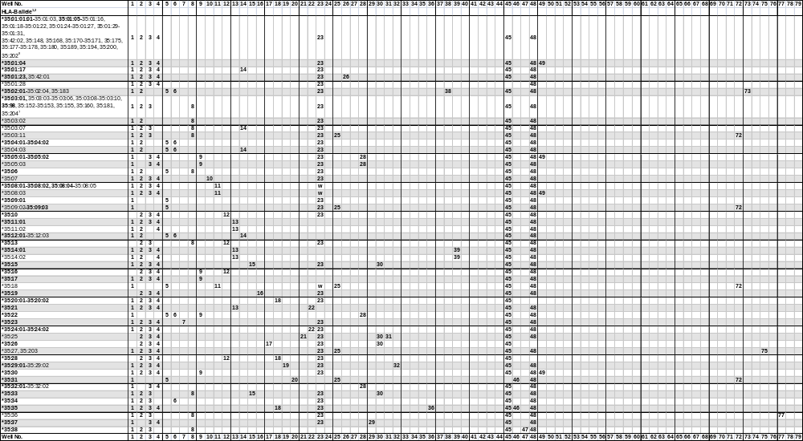
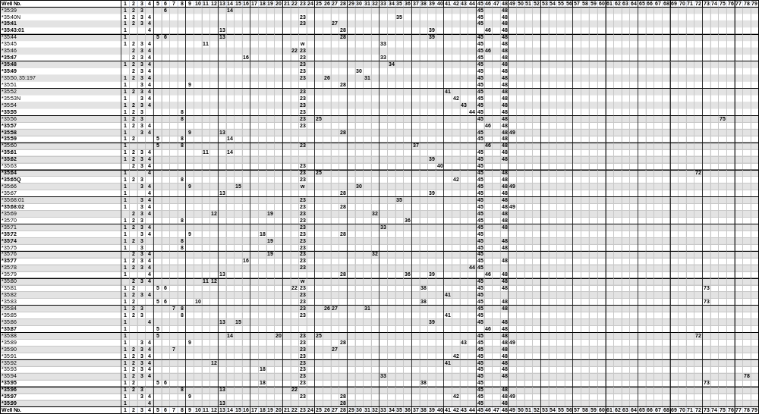
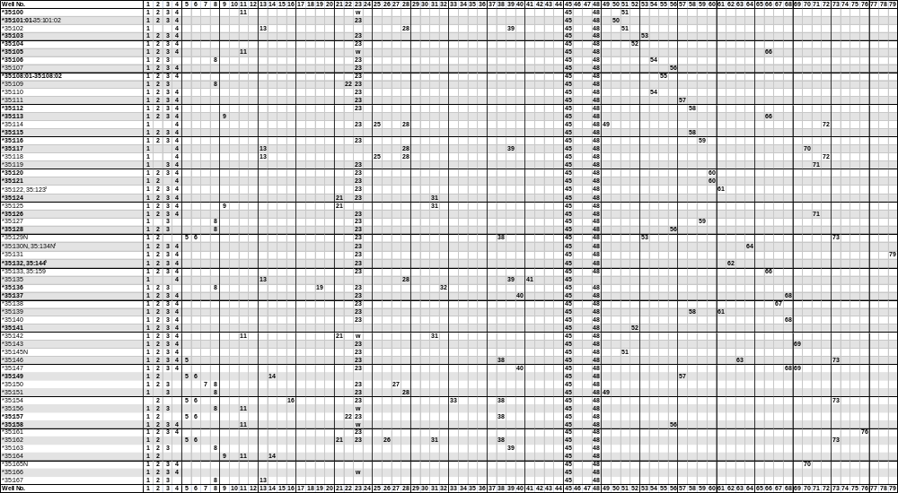
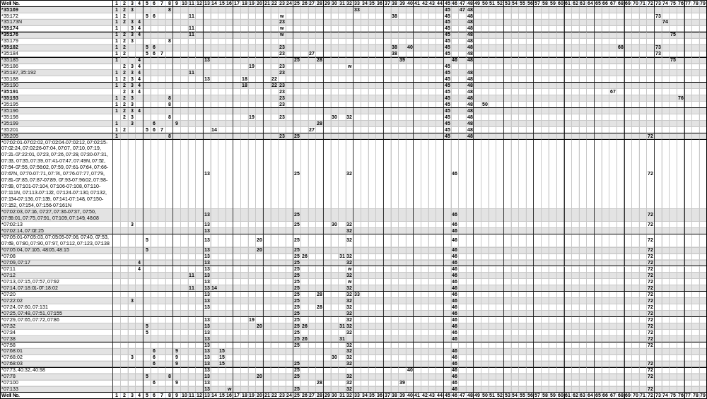
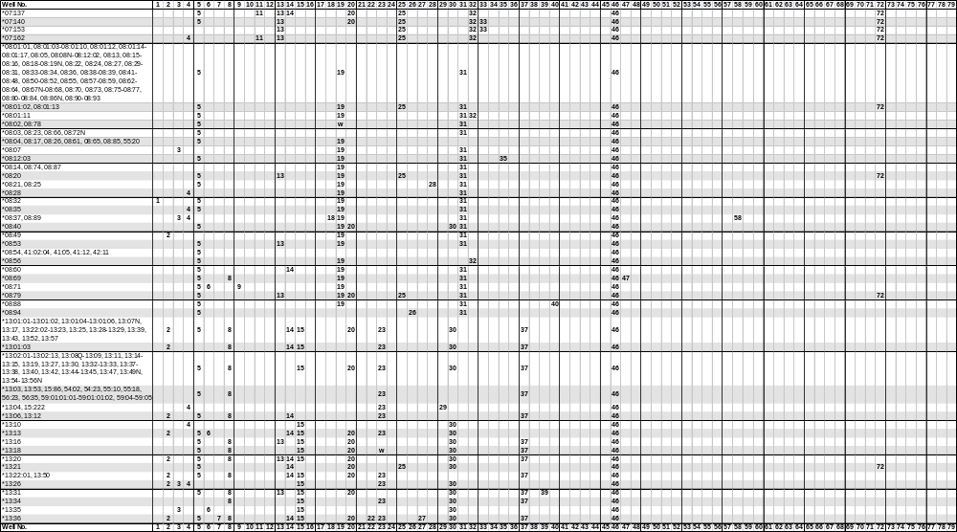
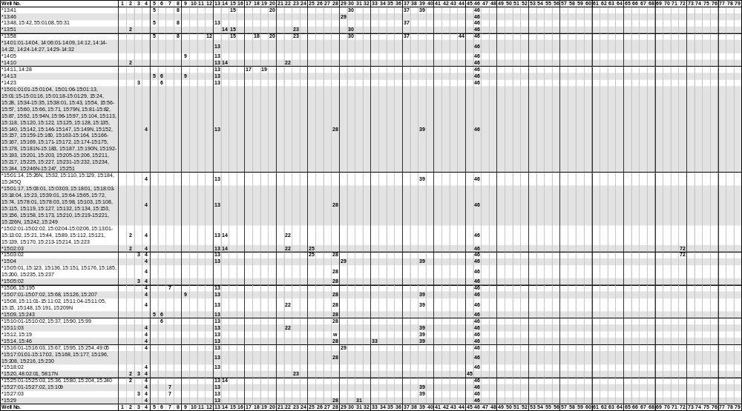
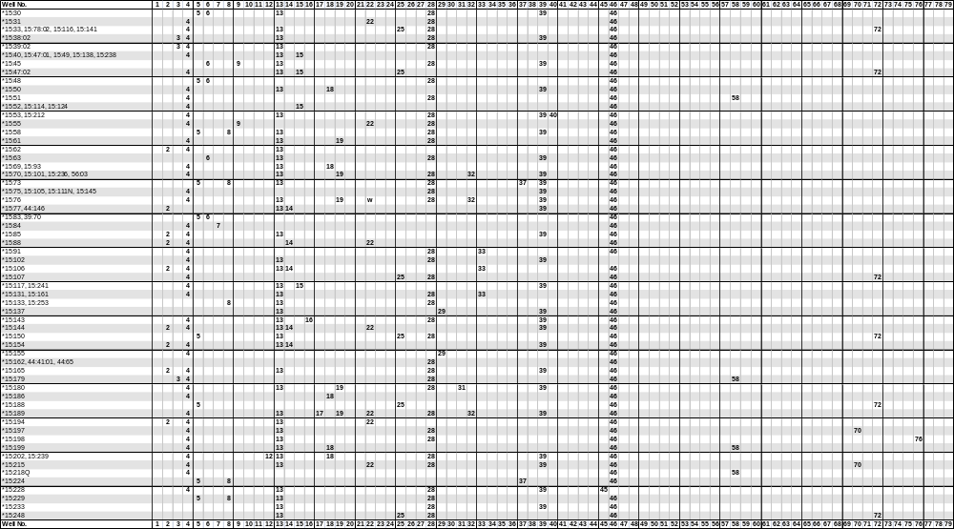
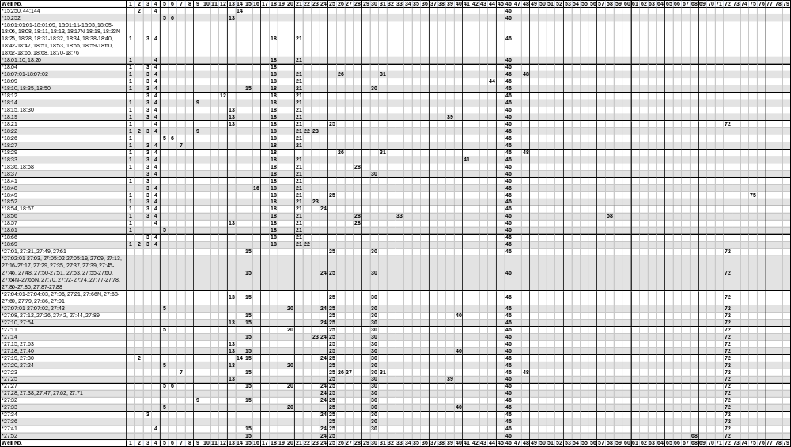
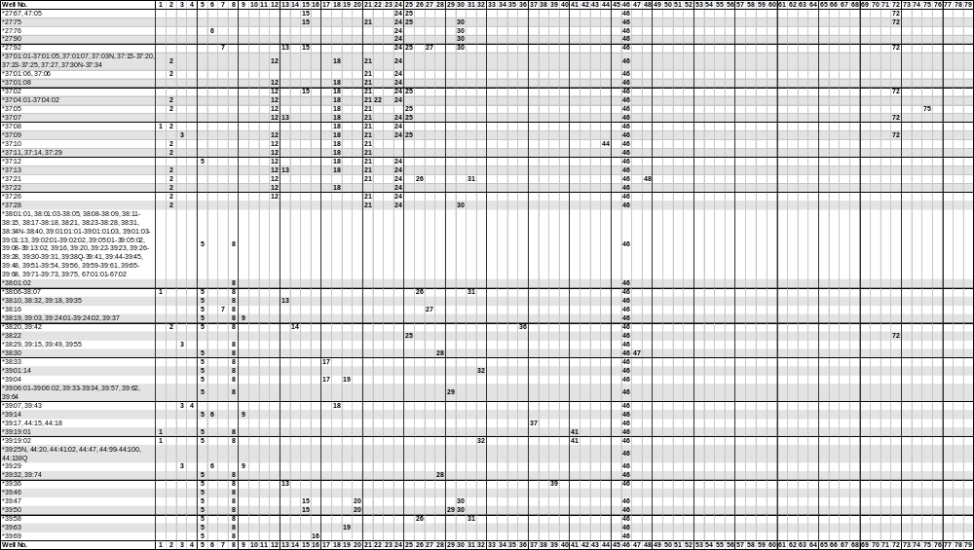
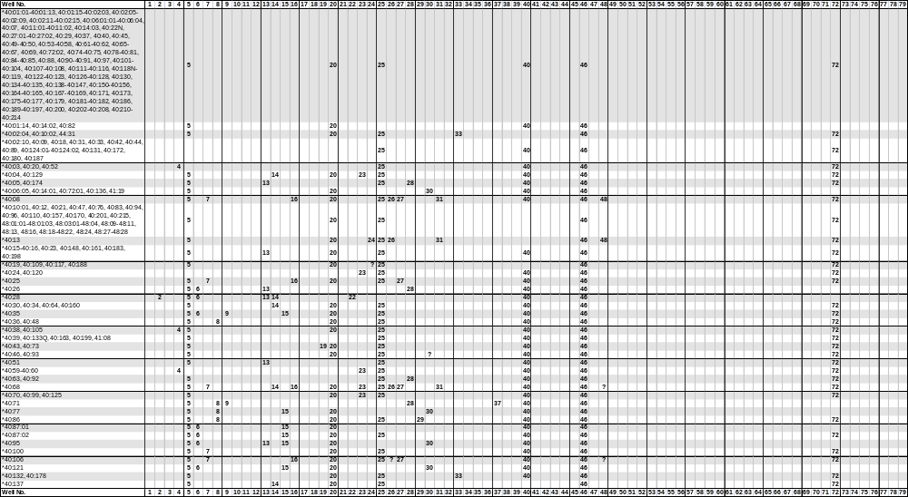
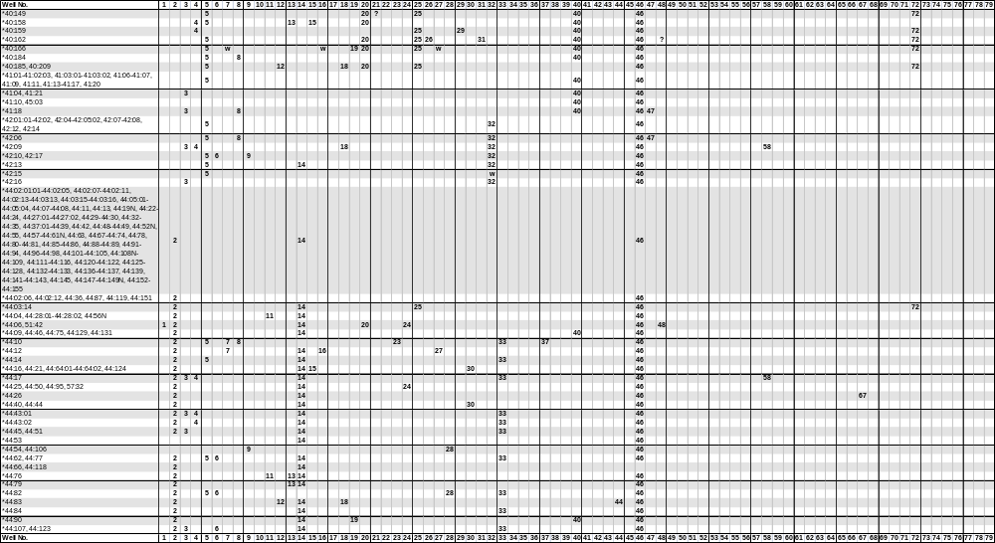
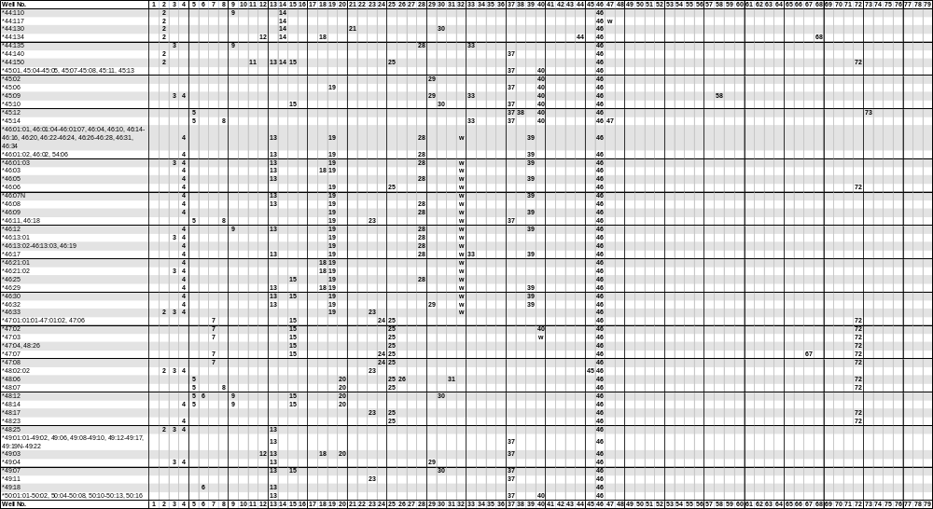
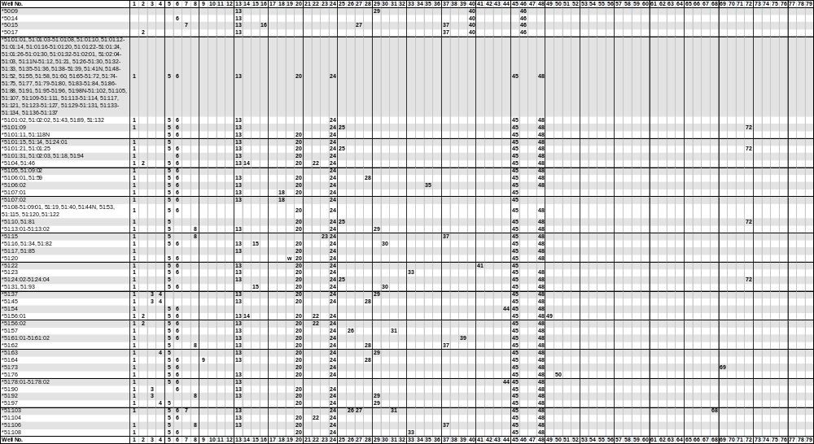
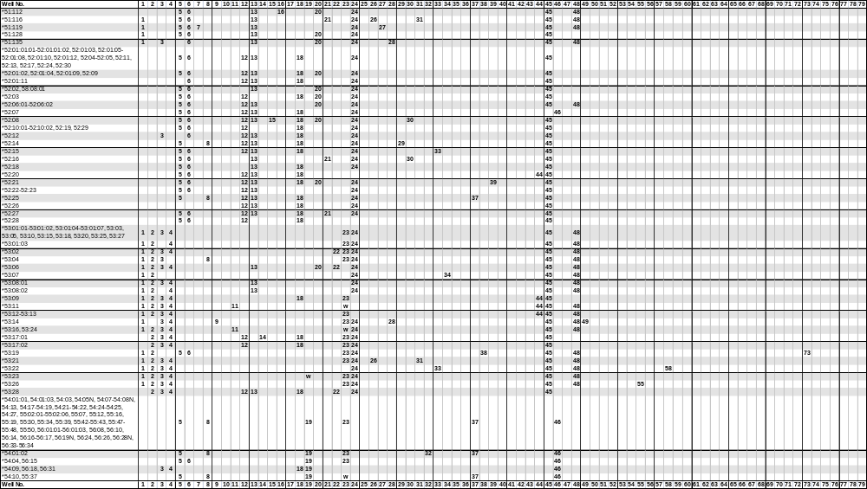
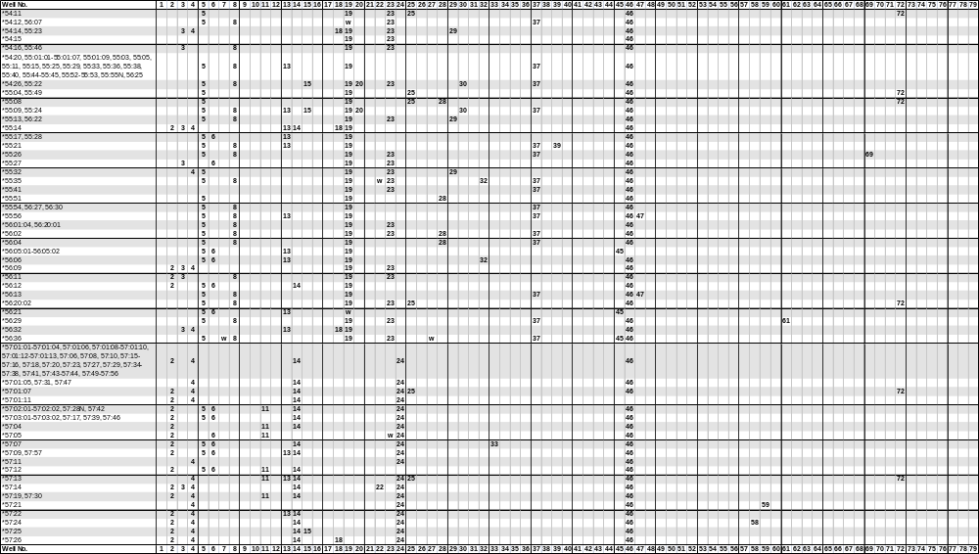
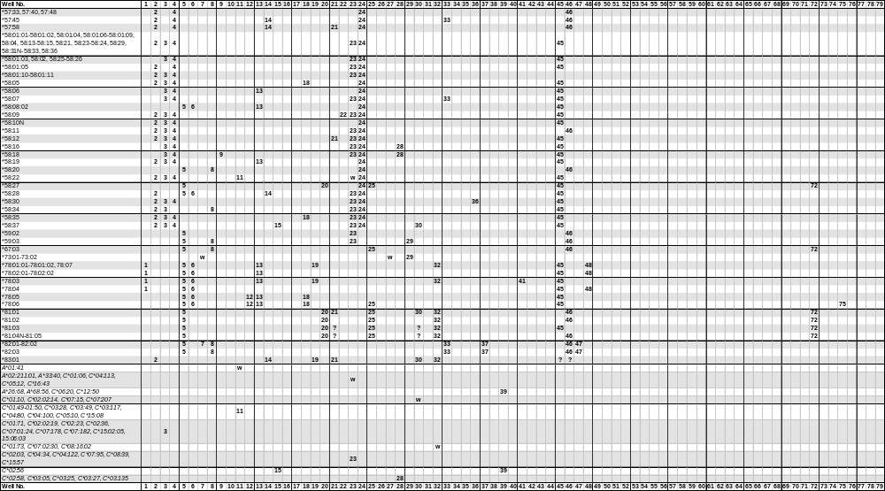
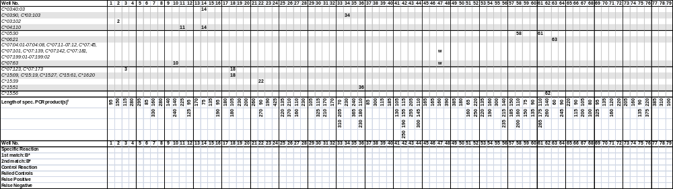
¹The B*3573 allele has been renamed to B*35:08:03. The B*35:43:02 allele has been renamed B*35:185.
²HLA-B*35 alleles in bold lettering are listed as confirmed alleles on the IMGT/HLA web page www.ebi.ac.uk/imgt/hla, release 3.9.0, July 2012.
³The B*35:122 and B*35:123 alleles can be distinguished by the different sizes of the specific PCR products generated by primer mix 61.
⁴The B*35:130N and B*35:134N alleles can be distinguished by the different sizes of the specific PCR products generated by primer mix 64.
⁵The B*35:132 and B*35:144 alleles can be distinguished by the different sizes of the specific PCR products generated by primer mix 62.
⁶Primer mix 7: Specific PCR fragment of 160 bp in the B*35:84, 35:90, 35:150, 35:184 and 35:201 and in the B*13:36, 27:23, 27:92, 38:16, 40:08, 40:25, 40:68, 40:106, 40:166^{w}, 44:12, 50:15, 51:103, 51:119, 56:36^{w} and 73:01^{w}-73:02^{w} alleles. Specific PCR fragment of 330 bp in the B*35:23 and the B*15:06, 15:27:01-15:27:03, 15:84, 15:109, 15:195, 18:27, 40:100, 44:10, 47:01:01:01-47:03, 47:06-47:08 and 82:01-82:02 alleles.
Primer mix 10: Specific PCR fragment of 140 bp in the B*35:83 and the C*07:63 alleles. Specific PCR fragment of 240 bp in the B*35:07 allele.
Primer mix 12: Specific PCR fragment of 95 bp in the B*35:10, 35:13, 35:16, 35:28, 35:69 and 35:80 and the B*13:58, 15:202, 15:239, 18:12, 37:01:01-37:01:05, 37:01:07-37:05, 37:07, 37:09-37:27, 37:29-37:34, 40:185, 40:209, 44:83, 44:134, 49:03, 52:01:01:01-52:01:12, 52:03-52:15, 52:17, 52:19-52:30, 53:17:01-53:17:02, 53:28 and 78:05-78:06 alleles. Specific PCR fragment of 125 bp in the B*35:92 allele.
Primer mix 16: Specific PCR fragment of 95 bp in the B*35:19, 35:47 and 35:154 and the B*07:133^{w}, 15:143, 18:48, 39:69, 40:08, 40:25, 40:68, 40:106, 40:166^{w}, 44:12, 50:15 and 51:112 alleles. Specific PCR fragment of 190 bp in the B*35:77 allele.
Primer mix 18: Specific PCR fragment of 105 bp in the B*35:20:01-35:20:02, 35:28, 35:72 and 35:95 and the B*13:58, 15:202, 15:239, 18:01:14, 18:10, 18:20-18:21, 18:26, 18:35-18:36, 18:41, 18:50, 18:56-18:58, 18:61, 37:01:01-37:01:05, 37:01:07-37:05, 37:07-37:20, 37:22-37:25, 37:27, 37:29-37:34, 40:185, 40:209, 44:83, 44:134, 49:03, 51:07:01-51:07:02, 52:01:01:01-52:01:12, 52:03-52:05, 52:07-52:15, 52:17-52:21, 52:24-52:30, 53:09, 53:17:01-53:17:02, 53:28 and 78:05-78:06 alleles. Specific PCR fragment of 180 bp in the B*35:35, 35:93, 35:188 and 35:190 and the B*08:37, 08:89, 15:50, 15:69, 15:93, 15:186, 15:199, 18:07, 18:29, 18:33, 18:37, 18:48, 18:66, 39:07, 39:43, 42:09, 46:03, 46:21:01-46:21:02, 46:29, 54:09, 54:14, 55:14, 55:23, 56:18, 56:31-56:32, 57:26, 58:05 and 58:35 and in the C*07:123, C*07:173, C*15:09, C*15:19, C*15:27, C*15:61 and C*16:20 alleles. Specific PCR fragment of 105 and 180 bp in the B*18:01:01:01-18:01:13, 18:01:15-18:06, 18:08-18:09, 18:11-18:15, 18:17N-18:19, 18:22-18:25, 18:27-18:28, 18:30-18:32, 18:34, 18:38-18:40, 18:42-18:47, 18:49, 18:51-18:55, 18:59-18:60, 18:62-18:65 and 18:67-18:76 alleles.
Primer mix 22: Specific PCR fragment of 90 bp in the B*35:46 and the B*13:36, 15:02:01-15:02:06, 15:08, 15:11:01-15:11:05, 15:13:01-15:13:02, 15:15, 15:21, 15:31, 15:44, 15:55, 15:76^{w}, 15:88-15:89, 15:112, 15:121, 15:139, 15:144, 15:148, 15:170, 15:189, 15:191, 15:194, 15:209N, 15:213-15:215, 15:223, 51:104 and 55:35^{w} alleles. Specific PCR fragment of 270 bp in the B*35:21, 35:24:01-35:24:02, 35:81, 35:96, 35:109, 35:157, 35:188 and 35:190 and the B*14:10, 18:22, 18:69, 37:04:01-37:04:02, 40:28, 51:04, 51:46, 51:56:01-51:56:02, 53:02, 53:06, 53:28, 57:14 and 58:09 and in the C*15:39 alleles.
Primer mix 25: Specific PCR fragment of 135 bp in the B*35:27, 35:56, 35:185, 35:203, 18:49, 37:05, 78:06 alleles. Specific PCR fragment of 220 bp in the B *35:03:11, 35:09:02-35:09:03, 35:18, 35:31, 35:64, 35:88, 35:114, 35:118, 35:205, 07:02:01-07:02:13, 07:02:15-07:02:24, 07:02:26-07:67N, 07:68:03-07:99, 07:101-07:162, 08:01:02, 08:01:13, 08:20, 08:79, 13:21, 15:02:03, 15:03:02, 15:33, 15:47:02, 15:78:02, 15:107, 15:116, 15:141, 15:150, 15:188, 15:248, 18:21, 27:01-27:21, 27:23-27:75, 27:77-27:89, 27:91-27:92, 37:02, 37:07, 37:09, 38:22, 40:01:01-40:01:13, 40:01:15-40:06:04, 40:07-40:13, 40:14:03-40:16, 40:18-40:25, 40:27:01-40:27:02, 40:29-40:40, 40:42-40:70, 40:72:02-40:76, 40:78-40:81, 40:83-40:86, 40:87:02-40:94, 40:96-40:120, 40:122-40:135, 40:137-40:157, 40:159-40:183, 40:185-40:215, 41:08, 44:03:14, 44:31, 44:150, 46:06, 47:01:01:01-47:08, 48:01:01-48:01:03, 48:03:01-48:11, 48:13, 48:15-48:24, 48:26-48:28, 51:01:09, 51:01:21, 51:01:25, 51:10, 51:24:02-51:24:04, 51:81, 54:11, 55:04, 55:08, 55:49, 56:20:02, 57:01:07, 57:13, 58:27, 67:03, 81:01-81:05 alleles.
Primer mix 26: Specific PCR fragment of 210 bp in the B*35:50, 35:84, 35:162 and 35:197 and the B*07:08, 07:32, 07:38, 08:94, 38:06-38:07, 39:58, 48:06, 51:57, 51:103^{w}, 51:116 and 53:21 alleles. Specific PCR fragment of 370 bp in the B*35:01:23, 35:42:01 and B*40:106? alleles. Specific PCR fragment of 210 and 370 bp in the B*18:07:01-18:07:02, 18:29, 27:23, 37:21, 40:08, 40:13, 40:68 and 40:162 alleles.
Primer mix 27: Specfic PCR fragment of 110 bp in the B*35:41 allele. Specific PCR fragment of 160 bp in the B*35:84, 35:90, 35:150, 35:184 and 35:201 and the B*13:36, 27:23, 27:92, 38:16, 40:08, 40:25, 40:68, 40:106, 40:166^{w}, 44:12, 50:15, 51:103, 51:119, 56:36^{w} and 73:01^{w}-73:02^{w} alleles.
Primer mix 30: Specific PCR fragment of 115 bp in the B*35:15, 35:33 and 35:66 and the B*07:02:13, 07:68:02, 08:40, 13:01:01-13:02:13, 13:07N-13:11, 13:13-13:21, 13:22:02-13:23, 13:25-13:45, 13:47, 13:49N, 13:51-13:52, 13:54-13:58, 18:10, 18:35, 18:50, 39:47, 39:50, 40:06:05, 40:14:01, 40:72:01, 40:77, 40:95, 40:121, 40:136, 41:19, 44:16, 44:21, 44:64:01-44:64:02, 44:124, 45:10, 48:12, 49:07, 51:16, 51:31, 51:34, 51:82, 51:93, 52:08, 54:26, 55:09, 55:22, 55:24 and 58:37 and in the C*01:10^{w}, C*02:02:14^{w}, C*07:15^{w} and C*07:207^{w} alleles. Specific PCR fragment of 325 bp in the B*35:25-35:26, 35:49 and 35:198 and the B*18:37, 27:01-27:21, 27:23-27:51, 27:53-27:66N, 27:68, 27:69, 27:91, 27:92, 37:28, 40:46?, 40:93?, 44:40, 44:44, 44:130, 52:16, 81:01, 81:03?-81:05? and 83:01 alleles. Specific PCR fragment of 115 and 325 bp in the B*27:90 allele.
Primer mix 31: Specific PCR fragment of 170 bp in the B*35:25, 35:124-35:125 and 35:142 and the B*08:01:01-08:03, 08:05, 08:07-08:16, 08:18-08:25, 08:27-08:53, 08:55, 08:57-08:60, 08:62-08:64, 08:66-08:84, 08:86N-08:93, 15:29 and 15:180 alleles. Specific PCR fragment of 210 bp in the B*35:50, 35:84 and 35:197 and the B*18:29, 27:23, 40:08, 40:13, 40:68, 40:162, 51:57, 51:103 and 53:21 alleles. Specific PCR fragment of 170 and 210 bp in the B*35:162 and in the B*07:08, 07:32, 07:38, 08:94, 18:07:01^{w}-18:07:02^{w}, 37:21, 38:06-38:07, 39:58, 48:06 and 51:116 alleles.
Primer mix 33: Specific PCR fragment of 70 bp in the B*35:47 and 35:154 and the B*15:46, 15:106, 40:02:04, 40:10:02, 44:84 and 57:45 alleles. Specific PCR fragment of 205 bp in the B*35:45, 35:71 and 35:169 and the B*07:20, 07:140, 07:153, 15:14, 15:91, 15:131, 15:161, 18:56, 40:132, 40:178, 44:10, 44:14, 44:17, 44:31, 44:43:01-44:43:02, 44:45, 44:51, 44:62, 44:77, 44:82, 44:107, 44:123, 44:135, 45:09, 45:14, 46:17, 51:23, 51:108, 52:15, 53:22, 57:07, 58:07 and 82:01-82:03 alleles. Specific PCR fragment of 310 bp in the B*35:94 allele.
Primer mix 35: Specific PCR fragment of 240 bp in the B*35:40N allele. Specific PCR fragment of 365 bp in the B*35:68:01 and the B*08:12:03 and 51:06:02 alleles.
Primer mix 36: Specific PCR fragment of 110 bp in the B*35:79 allele. Specific PCR fragment of 180 bp in the B*35:70 and the B*58:30 alleles. Specific PCR fragment of 230 bp in the B*35:35 and the B*38:20 and 39:42 and in the C*15:51 alleles.
Primer mix 41: Specific PCR fragment of 105 bp in the B*35:82, 35:85 and 35:135 and in the B*18:33, 39:19:01-39:19:02, 51:22 and 78:03 alleles. Specific PCR fragment of 130 bp in the B*35:52 and 35:92 alleles.
Primer mix 42: Specific PCR fragment of 115 bp in the B*35:97 allele. Specific PCR fragment of 155 bp in the B*35:53N allele. Specific PCR fragment of 190 bp in the B*35:91 allele. Specific PCR fragment of 250 bp in the B*35:65Q allele.
Primer mix 43: Specific PCR fragment of 205 bp in the B*35:54 allele. Specific PCR fragment of 255 bp in the B*35:89 allele.
Primer mix 44: Specific PCR fragment of 110 bp in the B*35:78 allele. Specific PCR fragment of 145 bp in the B*13:58, 18:09, 37:10, 44:83, 44:134, 51:54, 51:78:01-51:78:02, 52:20, 53:09 and 53:11-53:133 alleles. Specific PCR fragment of 300 bp in the B*35:55 allele.
Primer mix 51: Specific PCR fragment of 65 bp in the B*35:145N allele. Specific PCR fragment of 160 bp in the B*35:100 and 35:102 alleles.
Primer mix 52: Specific PCR fragment of 220 bp in the B*35:141 allele. Specific PCR fragment of 250 bp in the B*35:104 allele.
Primer mix 53: Specific PCR fragment of 135 bp in the B*35:103 allele. Specific PCR fragment of 220 bp in the B*35:129N allele.
Primer mix 54: Specific PCR fragment of 160 bp in the B*35:106 allele. Specific PCR fragment of 190 bp in the B*35:110 allele.
Primer mix 56: Specific PCR fragment of 140 bp in the B*35:128 allele. Specific PCR fragment of 215 bp in the B*35:107 allele. Specific PCR fragment of 235 bp in the B*35:158 allele.
Primer mix 57: Specific PCR fragment of 150 bp in the B*35:149 allele. Specific PCR fragment of 185 bp in the B*35:111 allele.
Primer mix 58: Specific PCR fragment of 110 bp in the B*35:139 and the C*05:30 alleles. Specific PCR fragment of 160 bp in the B*35:115 and the B*08:37, 08:89, 15:51, 15:179, 15:199, 15:218Q, 18:56, 42:09, 44:17, 45:09, 53:22 and 57:24 alleles. Specific PCR fragment of 200 bp in the B*35:112 allele.
Primer mix 59: Specific PCR fragment of 75 bp in the B*35:116 allele. Specific PCR fragment of 150 bp in the B*35:127 and the B*57:21 alleles.
Primer mix 60: Specific PCR fragment of 90 bp in the B*35:121 allele. Specific PCR fragment of 135 bp in the B*35:120 allele.
Primer mix 61: Specific PCR fragment of 110 bp in the B*35:139 and the C*05:30 alleles. Specific PCR fragment of 175 bp in the B*35:122 and the B*56:29 alleles. Specific PCR fragment of 265 bp in the B*35:123 allele.
Primer mix 62: Specific PCR fragment of 140 bp in the B*35:144 allele. Specific PCR fragment of 260 bp in the B*35:132 and the C*15:56 alleles.
Primer mix 64: Specific PCR fragment of 90 bp in the B*35:130N allele. Specific PCR fragment of 245 bp in the B*35:134N allele.
Primer mix 66: Specific PCR fragment of 90 bp in the B*35:133 allele. Specific PCR fragment of 115 bp in the B*35:105, 35:113 and 35:159 alleles.
Primer mix 67: Specific PCR fragment of 105 bp in the B*35:138 and the B*44:26 and 47:07 alleles. Specific PCR fragment of 200 bp in the B*35:191 allele.
Primer mix 68: Specific PCR fragment of 80 bp in the B*35:137, 35:147 and 35:182 and in the B*27:52, 44:134 and 51:103 alleles. Specific PCR fragment of 100 bp in the B*35:140 allele.
Primer mix 69: Specific PCR fragment of 95 bp in the B*35:143 and in the B*51:73 and 55:26 alleles. Specific PCR fragment of 325 bp in the B*35:147 allele.
Primer mix 71: Specific PCR fragment of 120 bp in the B*35:126 allele. Specific PCR fragment of 160 bp in the B*35:119 allele.
Primer mix 75: Specific PCR fragment of 90 bp in the B*35:176 allele. Specific PCR fragment of 135 bp in the B*35:27, 35:56, 35:185 and 35:203 and the B*18:49, 37:05 and 78:06 alleles.
Primer mix 76: Specific PCR fragment of 220 bp in the B*35:193 allele. Specific PCR fragment of 375 bp in the B*35:161 and the B*15:198 alleles.
⁷This lot of the B*35 subtyping kit cannot distinguish the B*35:98 and the B*35:03:01, 35:03:03-35:03:06 and 35:03:08-35:03:10 alleles.
⁸This lot of the B*35 subtyping kit cannot distinguish the B*35:01:01:01-35:01:03, 35:01:05-35:01:16, 35:01:18-35:01:22, 35:01:24-35:01:27 and 35:01:29-35:01:31 alleles and the B*35:148 allele.
‘w’, might be weakly amplified.
‘?’, nucleotide sequence of the primer matching region not known.

Change in revision R01 compared to R00:
- Primer mix 26 does not amplify the B*35:42:02 allele. This has been corrected in the specificity and interpretation tables.
Change in revision R02 compared to R01:
- Primer mix 46 does not amplify the B*35:96 and B*35:98 alleles. This has been corrected in the specificity and interpretation tables. Thus, this lot of the B*35 subtyping kit cannot distinguish the B*35:98 and the B*35:03:01, 35:03:03-35:03:06 and 35:03:08-35:03:10 alleles.
Change in revision R03 compared to R02:
- Primer mix 37 may amplify the C*03:102 allele. A foot note has been added in the Specificity Table.
Change in revision R04 compared to R03:
- Primer mix 65 does not amplify the B*35:148 allele. This has been corrected in the Specificity and Interpretation Tables. Thus, this lot of the HLA-B*15 subtyping kit cannot distinguish the B*35:01:01:01-35:01:03, 35:01:05-35:01:16, 35:01:18-35:01:22, 35:01:24-35:01:27 and 35:01:29-35:01:31 alleles and the B*35:148 allele.

